What Is Ash Wednesday? & Why Christians Celebrate It?
Each year, Ash Wednesday marks the beginning of Lent. Often called the Day of Ashes, Ash Wednesday starts Lent by focusing the Christian’s heart on repentance and prayer, usually through personal and communal confession. Here's what you need to know about this significant holiday.
Kelly GivensContributing Editor to Crosswalk.com

Each year, Ash Wednesday marks the beginning of Lent and is always 46 days before Easter Sunday. Lent is a 40-day season (not counting Sundays) marked by repentance, fasting, reflection, and ultimately celebration. The 40-day period represents Christ’s time of temptation in the wilderness, where he fasted and where Satan tempted him. Lent asks believers to set aside a time each year for similar fasting, marking an intentional season of focus on Christ’s life, ministry, sacrifice, and resurrection.
Contents
- Who Celebrates Ash Wednesday?
- What is Ash Wednesday and What Happens?
- Source and Meaning of the Ashes Used
- When is Ash Wednesday in 2020?
- The History of Lent and Ash Wednesday
- What Are You Not Allowed to Eat on Ash Wednesday?
- Is Ash Wednesday Only for Catholics, Or Can Protestants Celebrate Too?
- Verses to Reflect on for Ash Wednesday
- A Prayer for Ash Wednesday
- Sources

Who Celebrates Ash Wednesday?
Have you ever noticed how once a year, usually in February or March, there are a lot of people walking around with an ash cross on their foreheads? You probably knew it had something to do with Lent, but you weren’t sure why the ash cross was significant.
Or maybe, you grew up in a Catholic or Protestant church that held Ash Wednesday services each year, and so you’re already familiar with the service, but aren’t too sure about the history of Ash Wednesday and Lent, and what they have to do with the Christian faith. If you want to learn more about this important day in the liturgical calendar and why so many celebrate Ash Wednesday and Lent, read on!
Often called the Day of Ashes, Ash Wednesday starts Lent by focusing the Christian’s heart on repentance and prayer, usually through personal and communal confession. This happens during a special Ash Wednesday service.

What is the Meaning of Ash Wednesday and What Happens?

During Mass (for Catholics) or worship service (for Protestants), the priest or pastor will usually share a sermon that is penitential and reflective in nature. The mood is solemn - many services will have long periods of silence and worshipers will often leave the service in silence.
Usually, there is a responsive passage of Scripture, usually centered around confession, read aloud about the leader and congregation. Attendees will experience communal confession, as well as moments where they are prompted to silently confess sins and pray.
After all of this, the congregation will be invited to receive the ashes on their foreheads. Usually, as the priest or pastor will dip his finger into the ashes, spread them in a cross pattern on the forehead, and say, “From dust you came and from dust you will return.”

Where do the Ashes Come from and What do the Ashes Symbolize?
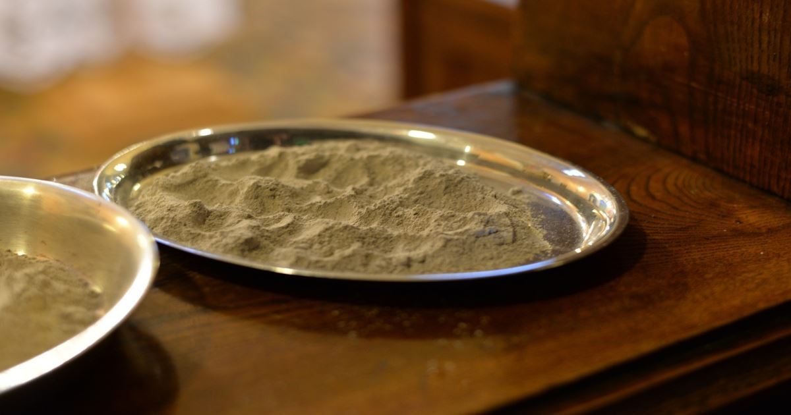
In many congregations, the ashes are prepared by burning palm branches from the previous Palm Sunday. On Palm Sunday, churches bless and hand out palm branches to attendees, a reference to the Gospels’ account of Jesus’ triumphal entry into Jerusalem, when onlookers lay palm branches on his path.
The ashes of this holiday symbolize two main things: death and repentance. “Ashes are equivalent to dust, and human flesh is composed of dust or clay (Genesis 2:7), and when a human corpse decomposes, it returns to dust or ash.”
“When we come forward to receive ashes on Ash Wednesday, we are saying that we are sorry for our sins, and that we want to use the season of Lent to correct our faults, purify our hearts, control our desires and grow in holiness so we will be prepared to celebrate Easter with great joy” (The CatholicSpirit.com).
With this focus on our own mortality and sinfulness, Christians can enter into the Lent season solemnly, while also looking forward in greater anticipation and joy of the message of Easter and Christ’s ultimate victory over sin and death.

When is Ash Wednesday in 2020?
Here are the important dates of Lent and when they occur in 2020:
Important Dates of Lent | Brief Overview of Significance | 2020 Date
Ash Wednesday | The beginning of Lent, a day of reflection and repentance from sin | February 26, 2020
Palm Sunday | Celebrates Jesus's triumphant entry into Jerusalem | April 5, 2020
Holy Week | The week leading up to Easter | April 5 - April 11, 2020
Maundy Thursday | Commemorates the foot washing and Last Supper of Jesus Christ with the Apostles | April 9, 2020
Good Friday | Commemorates the crucifixion of Jesus and his death at Calvary | April 10, 2020
Easter Sunday | Celebrates the resurrection of Jesus from the dead and his victory over sin and death. | April 12, 2020

The History of Lent and Ash Wednesday
The history and beginnings of Lent aren’t clear. According to Britannica.com, Lent has likely been observed: “since apostolic times, though the practice was not formalized until the First Council of Nicaea in 325 CE.” Christian scholars note that Lent became more regularized after the legalization of Christianity in A.D. 313. St. Irenaeus, Pope St. Victor I, and St. Athanasius all seem to have written about Lent during their ministries. Most agree that “by the end of the fourth century, the 40-day period of Easter preparation known as Lent existed, and that prayer and fasting constituted its primary spiritual exercises.”

What Are You Not Allowed to Eat on Ash Wednesday?
As far as the exact rules and practices of Lent, those have changed over the years. “In the early centuries fasting rules were strict, as they still are in Eastern churches,” notes Britannica.com. “One meal a day was allowed in the evening, and meat, fish, eggs, and butter were forbidden. The Eastern church also restricts the use of wine, oil, and dairy products. In the West, these fasting rules have gradually been relaxed. The strict law of fasting among Roman Catholics was dispensed with during World War II, and only Ash Wednesday and Good Friday are now kept as Lenten fast days.”

Is Ash Wednesday Only for Catholics, Or Can Protestants Celebrate Too?
Catholic, Orthodox and many (but not all) Protestants appreciate and observe Lent. Though Lent is not named or observed in the Bible, as Christianity Today notes, “the path of Lent—prayer, fasting, and generosity over a period of time—is heavily emphasized by the authors of and characters in the Bible, including Jesus. The Bible commands a lifestyle of worship and devotion that looks considerably like Lent. Therefore, while the word is absent in the Bible, the reality of Lent is woven throughout the whole of Scripture, as we have discovered.”
In his Gospel Coalition article Evangelicals Embracing (and Rejecting) Lent, Trevin Wax gives us an important reminder regardless of whether we personally observe Lent:
“I hardly think the church is suffering from too much fasting,” Wax says. “But I do think the church is suffering from too much self-righteousness (and I include myself in this indictment). Lent – being either for or against – can become a way of climbing up on to the pedestal.”
He goes on to say, “What is more important than the practices we take on is the heart attitude behind them. If there’s anything we should give up this time of year, it’s our sense of superiority either to those outside the church or those inside the church who do things differently than we do.”

Verses to Reflect on for Ash Wednesday:
If you’d like to start thinking through and observing Lent and Ash Wednesday, here are a few verses specific to Ash Wednesday to meditate and reflect on, and then a prayer you can pray to observe the day.
- Our Creation: Genesis 2:7 - Then the LORD God formed a man from the dust of the ground and breathed into his nostrils the breath of life, and the man became a living being.
- Our Curse: Genesis 3:19 - By the sweat of your brow you will eat your food until you return to the ground, since from it you were taken; for dust you are and to dust you will return.”
- Our Cry of Repentance: Psalm 51:7- 10: Cleanse me with hyssop, and I will be clean; wash me, and I will be whiter than snow. Let me hear joy and gladness; let the bones you have crushed rejoice. Hide your face from my sins and blot out all my iniquity. Create in me a pure heart, O God, and renew a steadfast spirit within me.

A Prayer for Ash Wednesday:
Lord, Holy One, have mercy on us. We confess our sins to you. We have fallen short of your glory and without your mercy and grace, we would be dust. We repent now. Lord, as we enter into this Lenten season, be near to us. Help us, by your Holy Spirit, to feel right conviction and repentance for our sin. Help us, by your Spirit, to have the strength to overcome the enemy.
Thank you, Lord, that Easter is coming! Death has no sting, no victory, because of Jesus! Glory and honor and praise to His name! Thank you for rescuing us. Help us keep both the weight and the joy of this season in our hearts and we move through the next several weeks. Help us bear the good fruit of your Spirit.
Thank you that the ashes on our forehead do not symbolize our ultimate reality. From dust we might have been formed, but our bodies, our spirits, ourselves, await beautiful redemption and the restoration of all things. Help us long and look forward to that day, and let it come quickly, Lord Jesus. Amen.

Sources:
- Time.com, Here's Where the Ashes for Ash Wednesday Come From, Mahita Gajanan (2017).
- TheCatholicSpirit.com, Why do we receive ashes on Ash Wednesday?, Father Michael Van Sloun (2016)
- Britannica.com, Lent, The Editors of Encyclopaedia Britannica.
- CatholicEducation.com, History of Lent, Fr. William Saunders, (2002)
- ChristianityToday.com, What’s the Deal with Lent?, Aaron Damiani (2017)
- TheGospelCoalition.org, Evangelicals Embracing (and Rejecting) Lent, Trevin Wax (2014)

This article is part of our larger Holy Week and Easter resource library centered around the events leading up to the death and resurrection of Jesus Christ. We hope these articles help you understand the meaning and story behind important Christian holidays and dates and encourage you as you take time to reflect on all that God has done for us through his son Jesus Christ!

