TEMPORARY PROFESSED WEEKEND SESSION.
VENUE: ST. LOUIS COMMUNITY, WA.
DATE: 16-17TH NOVEMBER, 2023.
This encounter is the second in a series of the Temporary Professed Weekend sessions held in the year, 2023. The encounter forms part of efforts aimed at meeting the ongoing formation needs and requirements of the Temporary Professed Brothers in the Province. Above all, the session provides a suitable platform and affords the young brothers the opportunity to bond and share their joys and challenges, helping to inspire and encourage one another in the process. For the first time in a while, the session recorded a hundred percent (100%) turnout; all twelve (12) Temporary Professed Brothers participated in the session: this is an unprecedented feat. It has often been very difficult getting all the young brothers to attend the program due to our different apostolic engagements.
The young brothers arrived on Thursday, November, 16 in the evening. We had supper together before meeting briefly in the St. Louis conference hall to be introduced to the program after which we retired to bed.
The following day, we kick-started the program with an inspiring and reflective prayer service led by Brs. Callistus Y. and Frederick K. This was immediately followed by a welcome address delivered by the Coordinator of TPBs, Br. Alpitio Kog, on behalf of the Provincial Superior, Br. Seregeous Dery.
The platform was then set for young brothers to share their experiences, encompassing both joys and challenges. It emerged from the sharing that each brother’s experiences was not entirely different from the other Brothers and that created a sense of similarity in what pertains to the FIC culture.
Our first resource person, Fr. John of God Kpierala, had already arrived to give his inputs on the topic, “Living Consecrated Life as a Temporary Professed Brother in the light of Spiritual Direction and Accompaniment.” Fr. John of God exhorted the young brothers to safeguard our vocation by taking our spiritual direction and accompaniment seriously. According to him, spiritual direction and accompaniment help to prevent deviations in the life. Further highlighting the importance of spiritual direction, he intimated that, the exercise helps us to desist from making a subjective interpretation of our experiences. This enables us to discern the true spirit from other spirits. The Holy Spirit is the principal director, assisted by human agents. Albeit the spiritual benefits of spiritual direction, some people don’t take it seriously or abandon it all together because of the following reasons: a narrow and poor understanding of the concept, a false sense of self-sufficiency, refusal to examine themselves, neglect of prayer and spiritual life etc. He concluded by admonishing the young brothers to be aware of the presence of God in our lives, hence the need to deepen our prayer life and conform our inner lives more closely to Christ through spiritual direction and accompaniment.
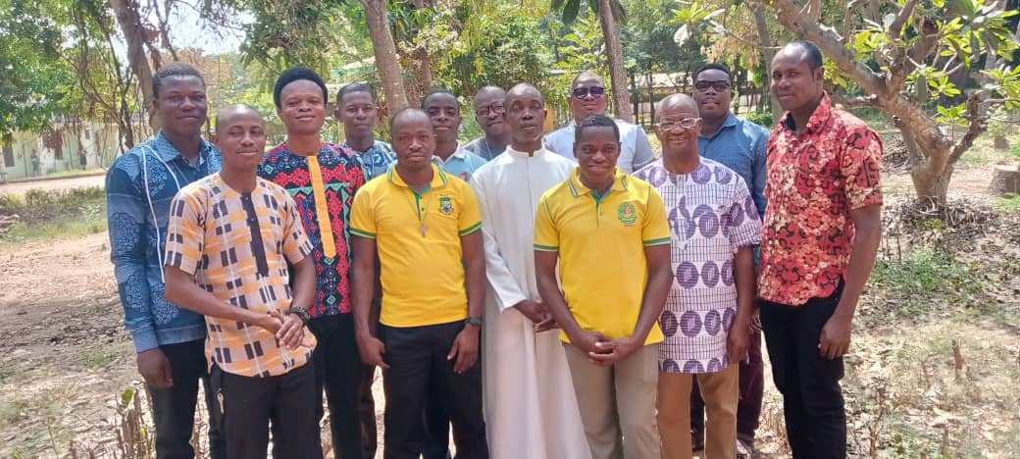
The young Brothers with Fr. John of God after his presentation.
Our second speaker for the day, Br. Methodius Kuusoru, also came through with his presentation. His topic was, “The Consecrated Life: A call to availability and service.” In his introduction, Br. Method painstakingly took us through the rich history of consecrated life, exposing us to the different categories therein. He talked about the Societies of Apostolic life such as Missionaries of Africa, the Circular Institutes such as Daughters of Charity and the Institute or Congregation of Religious Life where the Brothers FIC belong. He cautioned the young brothers to be wary of the greed and the crave for material possessions which have now become the order of the day in the world. He exhorted us to remain focused on our growth in the life amidst the myriads of challenges that confront us. There is the need to constantly ask ourselves, how resolved am I in my desire to follow Christ especially when faced with life’s storms and challenges? He further encouraged the young brothers to make their lives as profitable to the communities as possible, adding that we can derive a lot of fulfilment and enrichment from the service we render to our communities. We must endeavor to get actively involved in our community affairs to the extent that, when we are not around, our absence would be felt by the other community members.
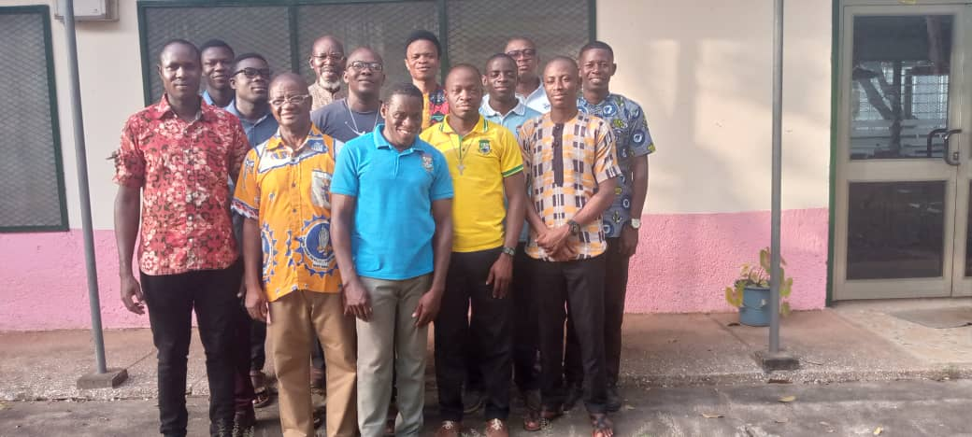
The young brothers with Br. Method after his presentation.
After the second presentation, we evaluated the entire session and brought proceedings to a close in the form of another prayer service. In a nutshell, the encounter was very fruitful and participants were enriched through the sharing and the inputs from the two resource persons.
Br. Prosper Ganye.

