Our Lady, our guide

Through her many apparitions over the centuries, Mary leads us more closely to her Son

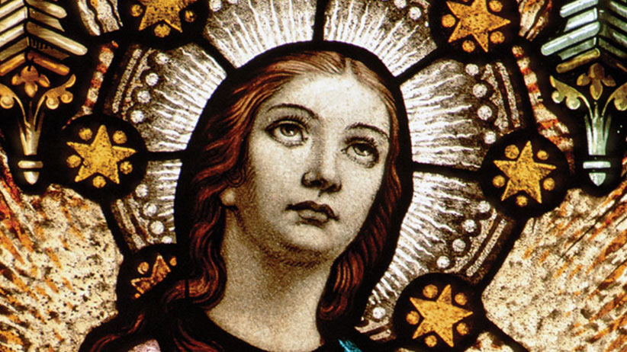

J.J. Ziegler OSV Newsweekly

Our Blessed Mother has appeared to many throughout the centuries. The Crosiers
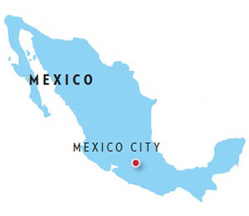
Mexico
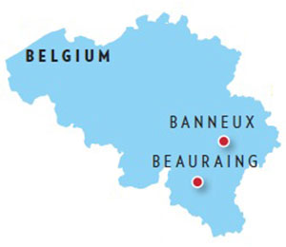
Belgium
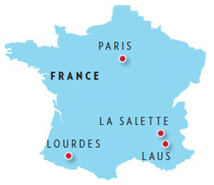
France
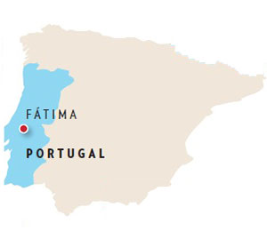
Portugal
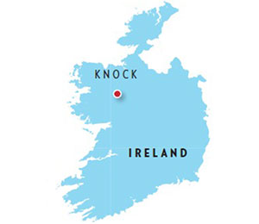
Ireland
Nearly 2,000 years ago, the author of the Letter to the Hebrews wrote that “In times past, God spoke in partial and various ways to our ancestors through the prophets; in these last days, he spoke to us through a son” (Heb 1:1-2). God did not abandon the world after creating it; instead, he revealed himself to our first parents, made a covenant with Noah, chose Abraham to be the father of a multitude of nations and formed his people of Israel.
In the fullness of time, God “said everything in his Word,” as the Catechism of the Catholic Church teaches. “Christ, the Son of God made man, is the Father’s one, perfect and unsurpassable word. In him he has said everything; there will be no other word than this one ... No new public revelation is to be expected before the glorious manifestation of our Lord Jesus Christ” (Nos. 65-66).
Even though God has already “said everything” through Jesus Christ, some Christians throughout the centuries have attested that they have seen or heard Jesus, the angels or the saints, especially the Blessed Mother. Thus “throughout the ages, there have been so-called ‘private’ revelations, some of which have been recognized by the authority of the Church,” as the catechism teaches (No. 67). “They do not belong, however, to the deposit of faith. It is not their role to improve or complete Christ’s definitive Revelation, but to help live more fully by it in a certain period of history.”
Pope Benedict XVI reflected on private revelation in his 2010 apostolic exhortationVerbum Domini (“The Word of the Lord”). “Ecclesiastical approval of a private revelation essentially means that its message contains nothing contrary to faith and morals,” he wrote; “it is licit to make it public and the faithful are authorized to give to it their prudent adhesion” (No. 46).
“A private revelation can introduce new emphases, give rise to new forms of piety, or deepen older ones,” Pope Benedict continued. “It can have a certain prophetic character and can be a valuable aid for better understanding and living the Gospel at a certain time; consequently it should not be treated lightly. It is a help which is proffered, but its use is not obligatory.”
What follows is a description of nine of the most influential approved Marian apparitions of the past five centuries.

Our Lady of Guadalupe
On Dec. 9-12, 1531, Our Lady appeared four times to St. Juan Diego Cuauhtlatoatzin (1474-1548), a member of the Chichimeca people and a convert, on the hill of Tepeyac near Mexico City.
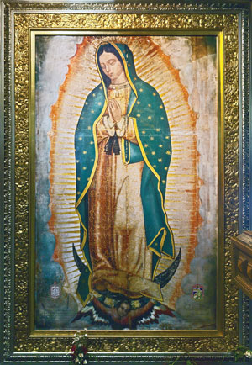
Shutterstock
“Know for certain, least of my sons, that I am the perfect and perpetual Virgin Mary, mother of Jesus, the true God, through whom everything lives, the Lord of all things near and far, the master of heaven and earth,” she said. “It is my earnest wish that a temple be built here to my honor. Here I will demonstrate, I will manifest, I will give all my love, my compassion, my help and my protection to the people.”
Our Lady asked Juan Diego to make known her request to Bishop Juan de Zumárraga. The bishop asked for a sign during a visit with Juan Diego. When he saw Our Lady again, she directed him to a hilltop where he saw a flower garden; he cut the roses and placed them in his cloak, or tilma. When he returned to the bishop, he opened his tilma; the roses fell to the floor, and the image of Our Lady of Guadalupe appeared miraculously on his tilma.
Numerous popes have referred to Our Lady of Guadalupe, and St. John Paul II visited her basilica in 1979, 1990, 1999 and 2002.
U.S. shrine: National Shrine of Our Lady of Guadalupe, Mother of the Americas (Allentown, Pa.)

Our Lady of Beauraing
In 1932 and 1933, Our Lady appeared 33 times to five children in Belgium. Revealing herself as the “Immaculate Virgin” and as “the Mother of God, Queen of Heaven,” she asked for a chapel to be built and said, “I will convert sinners.” Bishop André Marie Charue of Namur declared the apparitions supernatural in 1949.
St. John Paul II offered Mass at the shrine in 1985. He preached, “This place has become an important center of Marian pilgrimage, for the whole of Belgium and neighboring countries, a privileged place of prayer and renewal, where the faithful feel in a special way the presence of Mary, Immaculate Virgin, the Queen of Heaven, and her powerful intercession for the conversion of sinners.”

Our Lady of Banneux
In 1933, the Blessed Mother appeared eight times to a poor 11-year-old girl in Belgium. “I am the Virgin of the poor,” she said to Mariette Beco, and led her to a spring “reserved for all nations, for the sick.” Our Lady asked for the construction of a “small chapel” and said, “I come to relieve suffering.”
The chapel was built in 1933, and Bishop Louis-Joseph Kerkhofs of Liège declared the apparitions supernatural in 1949. St. John Paul II offered Mass at the shrine of Our Lady of Banneux in 1985, and Pope Benedict XVI wrote a letter in 2008 to commemorate the 75th anniversary of the apparitions.
“In 1933, a few years before the Second World War, Mary appeared in Banneux as a messenger of peace,” St. John Paul II said in a 1999 letter. “In a certain way she was summoning the leaders of society to become the artisans of peace and educators of peoples, inviting each person to care for his brothers and sisters, the lowliest, the most despised and the suffering, who are all beloved by God.”
U.S. shrine: Shrine of Our Lady, Virgin of the Poor (New Hope, Tenn.)

Our Lady of the Miraculous Medal
Click on the city to read about the apparition.
In 1830, the Blessed Virgin Mary appeared three times to St. Catherine Labouré (1806-76), a member of the Daughters of Charity of Saint Vincent de Paul. The second time, she saw Mary crushing a serpent, with rays coming forth from her hands. She also saw the words, “O Mary conceived without sin pray for us who have recourse to you,” and heard a voice say, “Have a medal made on this model. Those who will wear it with confidence will receive great graces.” In time, the archbishop of Paris consented to the request.
In 1980, St. John Paul II made a pilgrimage to the chapel in Paris where St. Catherine saw the apparitions. “You obtain from God, for us, all these graces that the rays of light that radiate from your open hands symbolize, on the sole condition that we dare to ask them of you, that we ourselves approach you with the confidence, the boldness, the simplicity of a child,” he prayed.
U.S. shrine: Shrine Chapel, Central Association of the Miraculous Medal (Philadelphia)

Our Lady of La Salette
In 1846, Our Lady appeared to two French children, Maximin Giraud (1835-75) and Mélanie Calvat (1831-1904), in southeastern France. She deplored sins of blasphemy, the refusal of most villagers to attend Mass in the summer and the lack of fidelity to Lenten discipline.
“If my people do not obey, I shall be compelled to loose my son’s arm,” she warned. “It is so heavy I can no longer restrain it.” Bishop Philibert de Bruillard of Grenoble approved the apparition in 1851.
“Mary, Mother full of love, in this place showed her sadness at the moral evil of humanity,” Pope St. John Paul II wrote in a letter marking the 150th anniversary of the apparition. “Through her tears, she helps us to better understand the painful gravity of sin, of the rejection of God, but also the passionate fidelity that her son keeps toward her children — he, the redeemer whose love is wounded by forgetfulness and refusal.”
U.S. shrine: National Shrine of Our Lady of La Salette (Attleboro, Mass.)

Our Lady of Lourdes
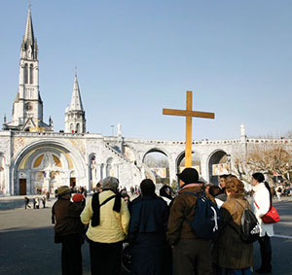
A pilgrim group gathers at the Sanctuaries of Our Lady of Lourdes in France. CNS photo
Our Lady appeared 18 times to St. Bernadette Soubirous (1844-79) in Lourdes, a town in southwestern France.
“From Feb. 11 to July 16, 1858, the Blessed Virgin Mary was pleased, as a new favor, to manifest herself in the territory of the Pyrenees to a pious and pure child of a poor, hardworking, Christian family,” Pope Pius XII wrote in a 1957 encyclical. Our Lady said on one occasion, “Penance! Penance! Penance! Pray to God for sinners. Kiss the ground as an act of penance for sinners.” After a spring began to flow, Our Lady said, “Go, tell the priests to come here in procession and to build a chapel here.” When Bernadette asked her to identify herself, she declared, “I am the Immaculate Conception.”
Bishop Bertrand-Sévère Mascarou-Laurence of Tarbes-et-Lourdes approved the apparitions in 1862. In 1911, St. Pius X wrote that the Lourdes shrine “surpasses in glory, it seems, all others in the Catholic world.” St. John Paul made pilgrimages there in 1983 and 2004, as did Pope Benedict XVI in 2008.
U.S. shrine: National Shrine Grotto of Lourdes (Emmitsburg, Md.)

Our Lady of Laus
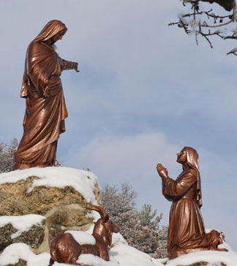
A monument in Laus depicts the Virgin Mary talking to Benoîte Rencurel. ND du Laus
In 1664, the Blessed Virgin began to appear frequently to Venerable Benoîte Rencurel (1647-1718), an illiterate shepherd girl in Saint-Étienne-le-Laus, a tiny village in southeastern France. She was entrusted with the task of constructing a church and a house for priests so they could hear pilgrims’ confessions.
In 1665, the local bishop approved the construction of a shrine, and 130,000 pilgrims flocked to Laus within 18 months. There were reports of numerous conversions and healings. Rencurel became a Third Order Dominican and lived a life of prayer and penance near the shrine. The Blessed Mother continued to appear to Rencurel until her death in 1718.
In 2008, after consulting with the Congregation for the Doctrine of the Faith, Bishop Jean-Michel di Falco Leandri of Gap, France, approved the Marian apparitions that took place during the last 54 years of Rencurel’s life. In 2009, Pope Benedict XVI declared that Rencurel lived the virtues heroically and conferred upon her the title Servant of God.

Our Lady of Fátima
In 1917, Our Lady of the Rosary appeared for six consecutive months to three Portuguese children: Lúcia Santos (1907-2005), Blessed Jacinta Marto (1910-20), and Blessed Francisco Marto (1908-19). Her message was one of prayer, atonement and devotion to her Immaculate Heart.
“Say the Rosary every day to bring peace to the world and an end to the war,” she said. “And after each one of the mysteries, my children, I want you to pray in this way: O my Jesus, forgive us our sins, save us from the fire of hell. Take all souls to heaven, especially those who are most in need.”
“Make sacrifices for sinners and say often, especially while making a sacrifice: O Jesus, this is for love of Thee, for the conversion of sinners, and in reparation for offences committed against the Immaculate Heart of Mary,” she added. She revealed to the children a three-part secret: a vision of hell, a request for the First Saturday devotion and consecration of Russia to the Immaculate Heart, and the killing of a bishop dressed in white, along with other clergy, religious and laity. Pope Pius XII, Pope Paul VI, St. John Paul II and Pope Francis have consecrated the world to Mary’s Immaculate Heart, and the Congregation for the Doctrine of the Faith released text of the third part of the secret in 2000, along with commentary.
During the final apparition on Oct. 13, Our Lady requested the construction of a chapel, and 70,000 onlookers witnessed the sun dance in the sky. Bishop José Alves Correia da Silva of Leiria-Fátima approved the apparitions in 1930, and Pope Paul VI (1967), Pope St. John Paul II (1982, 1991, 2000), and Pope Benedict XVI (2010) all made pilgrimages there.
U.S. shrine: Basilica of the National Shrine of Our Lady of Fatima (Lewiston, N.Y.)

Our Lady of Knock
In 1879, 15 people of all ages in Knock, Ireland, witnessed an apparition of the Blessed Mother, St. Joseph and St. John the Evangelist on a rainy evening; the Blessed Mother prayed but did not speak. Within months, Archbishop John McHale of Tuam found their testimony credible, and the site soon became a place of pilgrimage.
In 1979, St. John Paul II celebrated Mass at Knock and dedicated the Basilica of Our Lady, Queen of Ireland. “For a whole century now, you have sanctified this place of pilgrimage through your рrауеrs, through your sacrifice, through your penance,” he preached. “All those who have come here have received blessings through the intercession of Mary.”
“From that day of grace, 21 August 1879, until this very day, the sick and suffering, people handicapped in body or mind, troubled in their faith or their conscience, all have been healed, comforted and confirmed in their faith because they trusted that the mother of God would lead them to her son, Jesus,” he added.
J. J. Ziegler writes from North Carolina.
Our Lady of Good Help
After a yearlong investigation, on Dec. 8, 2010, Bishop David L. Ricken of the Diocese of Green Bay, Wis., issued a decree recognizing what is the only approved Marian apparition in the United States.
Three times in October 1859, Mary appeared to a Belgian immigrant, Adele Brise, in what is now Champion, Wis. The first two times Mary showed herself, Brise was too afraid to speak and hurried off. After telling her confessor about the apparitions, he urged her not to fear and to, in the name of God, ask the lady her name and what she desired.
The third and final time Mary appeared, with newfound courage and with two friends at her side, Brise did what the priest told her. Mary responded by saying, “I am Queen of Heaven, who prays for the conversion of sinners, and I wish you to do the same.” Brise’s companions could not see or hear Our Lady.
Mary went on to tell Brise to “Gather the children in this wild country and teach them what they should know for salvation. ... Teach them their catechism, how to sign themselves with the sign of the cross and how to approach the sacraments; that is what I wish you to do. Go and fear nothing. I will help you.”
Brise, who became a Third Order Franciscan, dedicated her life to building a chapel and school near the site of the apparition.

