MORNING PRAYER (10/10/2023)

IN THE SPIRIT OF OUR FOUNDERS
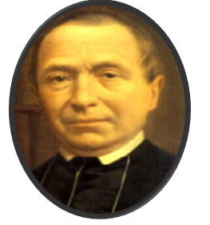
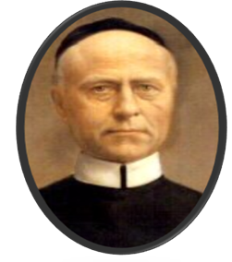

We honour both their names,
They laid the foundation stone,
We brothers keep on building,
In faith and grateful memory.

1. Introduction
Good morning brothers, welcome to this time of fraternal encounter in which our grateful hearts rejoice for feeling called around Jesus, who leads our life and our history in this pilgrimage through life as FIC brothers.
We know that our founders were committed people filled with the spirit of Jesus and we do our best to continue spreading the Good News in the world in the spirit of Louis and Bernard

2. Let us pray together
Thank you, Lord, for the vocation to the brotherhood.
Thank you, Lord, for my Community of brothers.
Thank you, Lord, because I see you reflected in all the people I live with.
Give me your light so that I can illuminate
those around me and those who gather for this oasis.
Accept the prayer that I offer you in my life
openly and with all sincerity.
Direct my steps of each day.
Correct me every time I stray off the path that you trace me.
Mary, mother of Jesus and our Patroness
Your Yes is the Yes of our surrender to Jesus. Amen.

3. Reading from the FIC Constitution Article 9
In the Spirit of our Founders

Our Founders were committed people, filled with the Spirit of Jesus. They were seized by his person and his message. They sensed a vocation and a mission to spread his Good News.
Living according to the spirit of our Founders means that we try to follow their example, in our time and in our circumstances, and that we protect their heritage.
Our Founders were inspired by the life and charitable works of Saint Vincent de Paul. They urged the brothers to follow his example. Living in the spirit of Saint Vincent implies for us:
- that we are aware that the goal of our apostolate is the greater glory of God and the growth of His Kingdom (see “Project” by Mgr. Rutten);
- that we have an open eye for both spiritual and material needs;
- that we listen carefully and humbly to the needs of others: “the poor are our masters”;
- that we empower others in overcoming their needs by offering formation and helping in self-organization;
- that we try to live the Vincentian virtues as reformulated by our co-founder: humility, good example, love for your brothers, godliness, prudence, gentleness, steadfastness, wisdom and knowledge, zeal and trust.

Article 10
Protecting their Heritage

Protecting their heritage of our founders implies for us:
- that we feel an intense concern for spiritual and religious needs; a great concern too for a contemporary and culturally integrated transfer of faith;
- that we see as our principal apostolic tradition: education, formation and teaching;
- that – in various circumstances- we, again and again, show a especial concern for the poor and the needy;
- that we keep an open eye to sound developments;
- that we attach great value to fraternal community life; we call one another brothers and intend to live up to this world in our everyday life;
- that we have a special veneration towards Mary.

4. Please, select only one sentence : pray with this sentence in a personal encounter with Jesus, Louis or Bernard

5. Let us pray with the intercessions:

- May our hearts be impregnated with the love of our founders: Msgr. Rutten and Brother Bernardus, to transform lives. Jesus, bless our mission.
- May each brother delivers the best version of his person at the service of the most vulnerable in our Provinces. Jesus bless our Mission.
- May Mary be the best way to Jesus and renew our vocation as FIC brothers in him every day. Jesus bless our Mission.
- May our communities be based on the real example of the love of Jesus, felt and expressed. Jesus bless our mission.
- May we be capable of protecting our apostolates against the dehumanizing currents of these times. Jesus bless our mission.

6. Our Father

7. Pray together
Send us your spirit, Jesus, and guide us on this day
illuminating our convictions, words, and projections.
May our founders be the example of free love that crosses borders.
In the name of the Father, and of the Son, and of the Holy Spirit. Amen

Personal prayer to our Founders (Gé)

8. Close Song:

Like our founders we have a special veneration towards Mary.
We hope and trust that Mary will accompany us on our journey in this OASIS

Ven con nosotros al caminar Santa María, ven | Come with us, Mary, as we walk!
1. Mientras recorres la vida tú nunca solo estas:  Contigo por el camino Santa María, va  Refrán:  Ven con nosotros al caminar Santa María, ven; (x2)  2. Aunque te digan algunos que nada puede cambiar.  Lucha por un mundo nuevo, lucha por la verdad.  3. Si por el mundo los hombres sin conocerse van,  No niegues nunca tu mano al que contigo está  4. Aunque parezcan tus pasos inútil caminar,  Tú vas haciendo caminos, otros los seguirán | 1. You are never alone in life;  Mary is with you on your journey.  Refrain:  Come with us, Mary, as we walk ! (x2)  2. Even if someone tells you that nothing can change.  Fight for a new world, fight for the truth.  3. Even if others in the world don’t recognize you,  Still, reach out to those who are with you.  4. Even when it seems useless to keep going,  Stay the course, and others will follow you.

