Meditation  Devotion to the Sacred Heart, as we know it, began about the year 1672. On repeated occasions, Jesus appeared to Saint Margaret Mary Alacoque, a Visitation nun, in France, and during these apparitions He explained to her the devotion to His Sacred Heart as He wanted people to practice it. he asked to be honored in the symbol of His Heart of flesh; he asked for acts of reparation, for frequent Communion, Communion on the First Friday of the month, and the keeping of the Holy Hour.  When the Catholic Church approved the devotion to the Sacred Heart of Jesus, she did not base her action only on the visions of Saint Margaret Mary. The Church approved the devotion on its own merits. There is only one Person in Jesus, and that Person was at the same time God and Man. His Heart, too, is Divine -- it is the Heart of God.  There are two things that must always be found together in the devotion to the Sacred Heart: Christ's Heart of flesh and Christ's love for us. True devotion to the Sacred Heart means devotion to the Divine Heart of Christ insofar as His Heart represents and recalls His love for us.  In honoring the Heart of Christ, our homage lingers on the Person of Jesus in the fullness of His love. This love of Christ for us was the moving force of all he did and suffered for us -- in Nazareth, on the Cross, in giving Himself in the Blessed Sacrament, in His teaching and healing, in His praying and working. When we speak of the Sacred Heart, we mean Jesus showing us His Heart, Jesus all love for us and all lovable.  Jesus Christ is the incarnation of God's infinite love. The Human Nature which the Son of God took upon Himself was filled with love and kindness that has never found an equal. He is the perfect model of love of God and neighbor.  Every day of His life was filled with repeated proofs of "Christ's love that surpasses all knowledge" (Eph 3:19). Jesus handed down for all time the fundamental feature of His character: "Take My yoke upon your shoulders and learn from Me, for I am meek and humble of Heart" (Mt 11:29). He invited all, refusing none, surprising friends and rivals by His unconditional generosity.  The meaning of love in the life of Jesus was especially evident in His sufferings. Out of love for His Father He willed to undergo the death of the Cross. "The world must know that I love the Father and do just as the Father has commanded Me" (Jn 14:31).  The love that Jesus bore toward us also urged Him to undergo the death of the Cross. At the Last Supper, He said, "There is no greater love than to lay down one's life for one's friends" (Jn 15:13)  The Heart of Jesus never ceases to love us in heaven. He sanctifies us through the Sacraments. These are inexhaustible fountains of grace and holiness which have their source in the boundless ocean of the Sacred Heart of Jesus. | 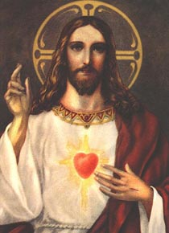
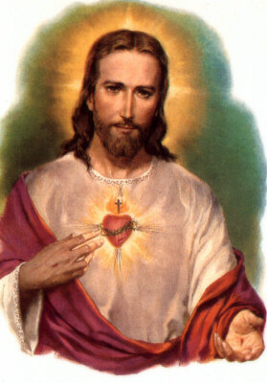 | Novena Prayer  Divine Jesus, You have said, "Ask and you shall receive; seek and you shall find; knock and it shall be opened to you." Behold me kneeling at Your feet, filled with a lively faith and confidence in the promises dictated by Your Sacred Heart to Saint Margaret Mary. I come to ask this favor: Mention your request).  To whom can I turn if not to You, Whose Heart is the source of all graces and merits? Where should I seek if not in the treasure which contains all the riches of Your kindness and mercy? Where should I knock if not at the door through which God gives Himself to us and through which we go to God? I have recourse to You, Heart of Jesus. In You I find consolation when afflicted, protection when persecuted, strength when burdened with trials, and light in doubt and darkness.  Dear Jesus, I firmly believe that You can grant me the grace I implore, even though it should require a miracle. You have only to will it and my prayer will be granted. I admit that I am most unworthy of Your favors, but this is not a reason for me to be discouraged. You are the God of mercy, and You will not refuse a contrite heart. Cast upon me a look of mercy, I beg of You, and Your kind Heart will find in my miseries and weakness a reason for granting my prayer.  Sacred Heart, whatever may be Your decision with regard to my request, I will never stop adoring, loving, praising, and serving You. My Jesus, be pleased to accept this my act of perfect resignation to the decrees of Your adorable Heart, which I sincerely desire may be fulfilled in and by me and all Your creatures forever.  Grant me the grace for which I humbly implore You through the Immaculate Heart of Your most sorrowful Mother. You entrusted me to her as her child, and her prayers are all-powerful with You. Amen.
Offering  My God, I offer You all my prayers, works, joys, and sufferings in union with the Sacred Heart of Jesus, for the intentions for which He pleads and offers Himself in the Holy Sacrifice of the Mass, in thanksgiving for Your favors, in reparation for my sins, and in humble supplication for my temporal and eternal welfare, for the needs of our holy Mother the Church, for the conversion of sinners, and for the relief of the poor souls in purgatory.  Taken from:  https://www.ewtn.com/Devotionals/heart/meditation.htm | 