MALAWI 2024 PROVINCIAL DAY GATHERING
The FIC Constitutions article 36 encourages us to be a brother to one another, this is much felt when we gather together as brothers and share both our happiness and sorrows. Our gatherings promote a sense of belonging and unity. It creates room for sharing
collective wisdom, experiences, insights and lasting memories. One of such gatherings in our province is the Provincial Day. A day in which all brothers come together to exchange ideas, knowledge, hopes and perspectives leading to personal growth and development of the province.

On 1st May 2024, being a public holiday, all the brothers gathered at Bethel community, the Provincial house. We were privileged to be joined by representatives of Dynapharm Company which makes food supplements that are totally organic. They made a presentation on how we can take care of our bodies to have a balanced health body system. They took the brothers on a range of health issues that usually characterize our lives as we age and how we could either prevent ourselves from being affected or reduce their severity on our lives. Health issues/conditions and/or diseases that formed the core of the first part of the day’s discussion and/or presentation were Cancer, stroke, high blood pressure and diabetes, but just to mention a few.
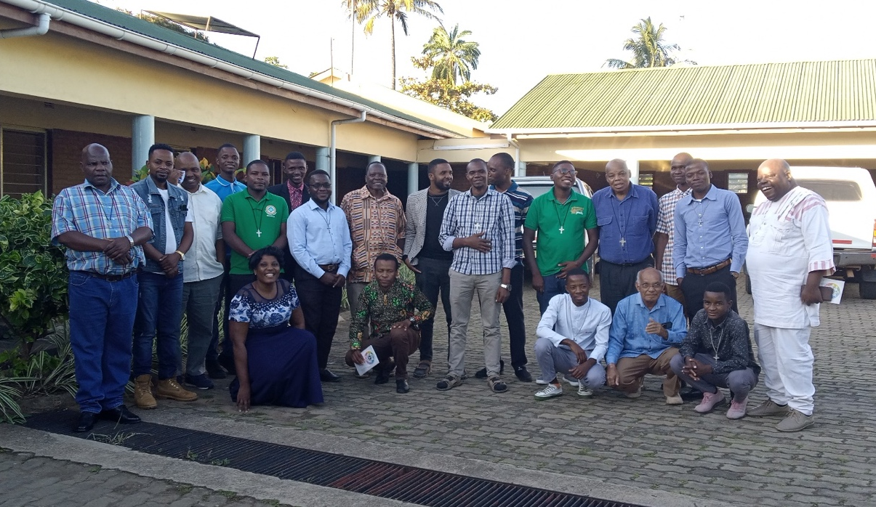
Group photo of the brothers together with representatives from Dynapharm
The second part of the Provincial day was dedicated to the sharing of experiences by the FIC Journey to Spiritual Enrichment participants that took place in the Netherlands, the Cradle of the congregation during the Deepening Stage. Brothers. Mike Mbato and Bonaventure Kasiya were given time to make personal presentation of their experiences of the spiritual journey. Brother Pascal Mtuwana, the animator of the participants in Malawi made an introductory note. Then both the participants shared their experiences.

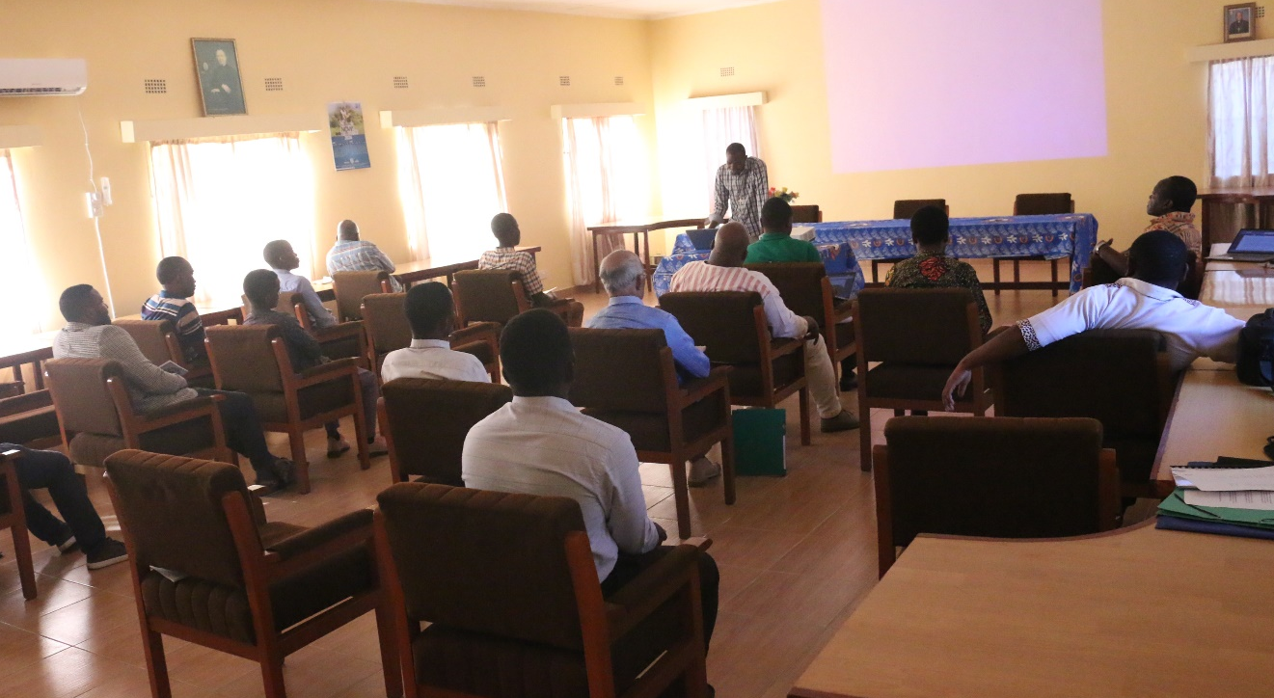
Bro. Mike Mbato sharing his experience of OASIS gathering

In his speech during the gathering, the Provincial Superior, Bro. Lawrence Sitima, thanked the participants of OASIS for the commitment displayed from the onset and during the exercise. He pleaded with participant to continue the journey and to share their experiences with fellow community members, fellow brothers in the province, with those who work with them in their various apostolates, with the local church through faith sharing with the youth and other congregants, and with those that they interact with on daily basis through the testimony of their daily living. Lastly, we proceeded to Bethel lounge to celebrate the 61st belated birthday of Bro. Pascal Mtuwana.

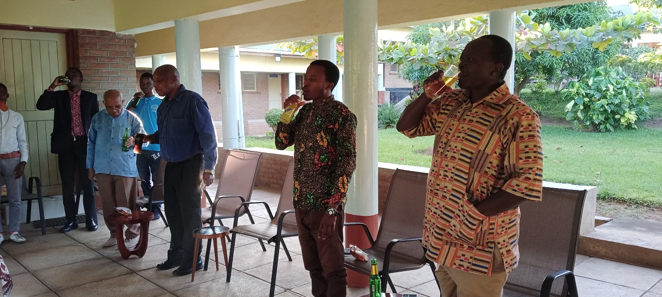
Brothers celebrating the belated birthday of Bro. Pascal Mtuwana

Compiled by Bro. Gasper Kalisto

