“Fratelli tutti”: long summary of Pope Francis's Social Encyclical

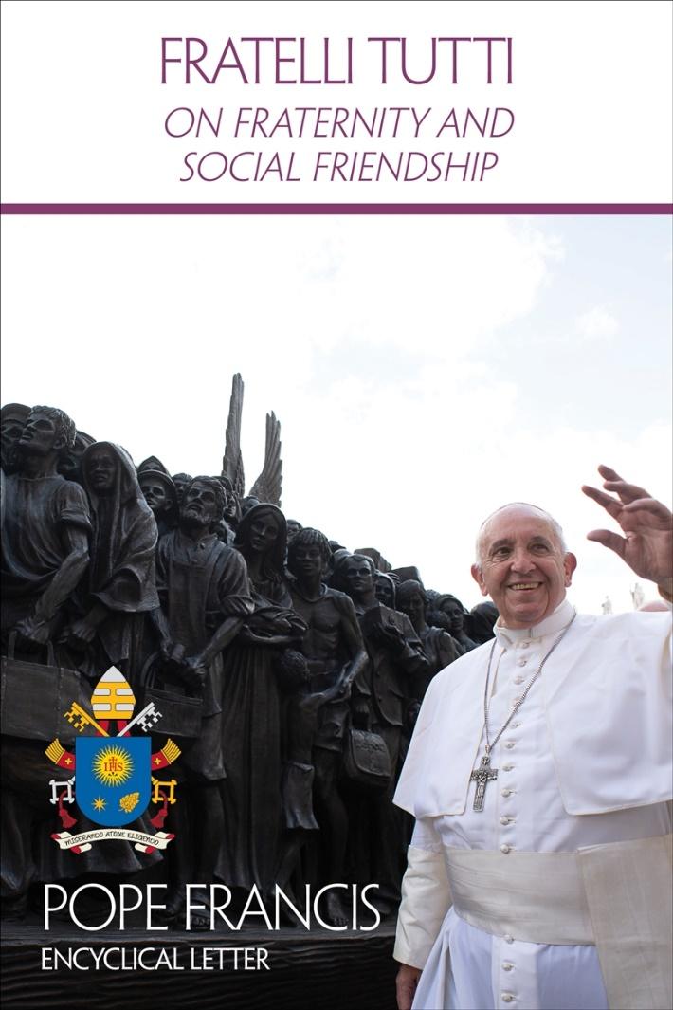
Fraternity and social friendship are the ways the Pontiff indicates to build a better, more just and peaceful world, with the contribution of all: people and institutions. With an emphatic confirmation of a ‘no’ to war and to globalized indifference.
By Isabella Piro – Vatican City
What are the great ideals but also the tangible ways to advance for those who wish to build a more just and fraternal world in their ordinary relationships, in social life, politics and institutions? This is mainly the question that Fratelli tutti is intended to answer: the Pope describes it as a “Social Encyclical” (6) which borrows the title of the “Admonitions” of Saint Francis of Assisi, who used these words to “address his brothers and sisters and proposed to them a way of life marked by the flavour of the Gospel” (1). The Poverello “did not wage a war of words aimed at imposing doctrines; he simply spread the love of God”, the Pope writes, and “he became a father to all and inspired the vision of a fraternal society” (2-4). The Encyclical aims to promote a universal aspiration toward fraternity and social friendship. Beginning with our common membership in the human family, from the acknowledgement that we are brothers and sisters because we are the children of one Creator, all in the same boat, and hence we need to be aware that in a globalized and interconnected world, only together can we be saved. The Document on Human Fraternity signed by Francis and the Grand Imam of Al-Azhar in February 2019 is an inspirational influence cited many times.
Fraternity is to be encouraged not only in words, but in deeds. Deeds made tangible in a “better kind of politics”, which is not subordinated to financial interests, but to serving the common good, able to place the dignity of every human being at the centre and assure work to everyone, so that each one can develop his or her own abilities. A politics which, removed from populism, is able to find solutions to what attacks fundamental human rights and which aims to definitively eliminate hunger and trafficking. At the same time, Pope Francis underscores that a more just world is achieved by promoting peace, which is not merely the absence of war; it demands “craftsmanship”, a job that involves everyone. Linked to truth, peace and reconciliation must be “proactive”; they must work toward justice through dialogue, in the name of mutual development. This begets the Pontiff's condemnation of war, the “negation of all rights” and is no longer conceivable even in a hypothetically “justified” form, because nuclear, chemical and biological weapons already have enormous repercussions on innocent civilians. There is also a strong rejection of the death penalty, defined as “inadmissible”, and a central reflection on forgiveness, connected to the concepts of remembrance and justice: to forgive does not mean to forget, the Pontiff writes, nor to give up defending one's rights to safeguard one's dignity, which is a gift from God. In the background of the Encyclical is the Covid-19 pandemic which, Francis reveals, “unexpectedly erupted” as he “was writing this letter”. But the global health emergency has helped demonstrate that “no one can face life in isolation” and that the time has truly come to “dream, then, as a single human family” in which we are “brothers and sisters all” (7-8).

Global problems, global actions
Opened by a brief introduction and divided into eight chapters, the Encyclical gathers – as the Pope himself explains – many of his statements on fraternity and social friendship, arranged, however, “in a broader context of reflection” and complemented by “a number of letters, documents” sent to Francis by “many individuals and groups throughout the world” (5). In the first chapter, “Dark clouds over a closed world”, the document reflects on the many distortions of the contemporary era: the manipulation and deformation of concepts such as democracy, freedom, justice; the loss of the meaning of the social community and history; selfishness and indifference toward the common good; the prevalence of a market logic based on profit and the culture of waste; unemployment, racism, poverty; the disparity of rights and its aberrations such as slavery, trafficking, women subjugated and then forced to abort, organ trafficking (10-24). It deals with global problems that call for global actions, emphasizes the Pope, also sounding the alarm against a “culture of walls” that favours the proliferation of organized crime, fuelled by fear and loneliness (27-28). Moreover, today we observe a deterioration of ethics (29), contributed to, in a certain way, by the mass media which shatter respect for others and eliminate all discretion, creating isolated and self-referential virtual circles, in which freedom is an illusion and dialogue is not constructive (42-50).

Love builds bridges: the Good Samaritan
To many shadows, however, the Encyclical responds with a luminous example, a herald of hope: the Good Samaritan. The second chapter, “A stranger on the road”, is dedicated to this figure. In it, the Pope emphasizes that, in an unhealthy society that turns its back on suffering and that is “illiterate” in caring for the frail and vulnerable (64-65), we are all called – just like the Good Samaritan – to become neighbours to others (81), overcoming prejudices, personal interests, historic and cultural barriers. We all, in fact, are co-responsible in creating a society that is able to include, integrate and lift up those who have fallen or are suffering (77). Love builds bridges and “we were made for love” (88), the Pope adds, particularly exhorting Christians to recognize Christ in the face of every excluded person (85). The principle of the capacity to love according to “a universal dimension” (83) is also resumed in the third chapter, “Envisaging and engendering an open world”. In this chapter Francis exhorts us to go “‘outside’ the self” in order to find “a fuller existence in another” (88), opening ourselves up to the other according to the dynamism of charity which makes us tend toward “universal fulfilment” (95). In the background – the Encyclical recalls – the spiritual stature of a person’s life is measured by love, which always “takes first place” and leads us to seek better for the life of the other, far from all selfishness (92-93).

Rights have no borders
A fraternal society, therefore, will be one that promotes educating in dialogue in order to defeat the “virus” of “radical individualism” (105) and to allow everyone to give the best of themselves. Beginning with protection of the family and respect for its “primary and vital mission of education” (114). There are two ‘tools’ in particular to achieve this type of society: benevolence, or truly wanting good for the other (112), and solidarity which cares for fragility and is expressed in service to people and not to ideologies, fighting against poverty and inequality (115). The right to live with dignity cannot be denied to anyone, the Pope again affirms, and since rights have no borders, no one can remain excluded, regardless of where they are born (121). In this perspective the Pontiff also calls us to consider “an ethics of international relations” (126), because every country also belongs to foreigners and the goods of the territory cannot be denied to those who are in need and come from another place. Thus, the natural right to private property will be secondary to the principal of the universal destination of created goods (120). The Encyclical also places specific emphasis on the issue of foreign debt: subject to the principal that it must be paid, it is hoped nonetheless that this does not compromise the growth and subsistence of the poorest countries (126).

Migrants: global governance for long-term planning
Meanwhile, part of the second and the entire fourth chapter are dedicated to the theme of migration, the latter, entitled “A heart open to the whole world”. With their lives “at stake” (37), fleeing from war, persecution, natural catastrophes, unscrupulous trafficking, ripped from their communities of origin, migrants are to be welcomed, protected, supported and integrated. Unnecessary migration needs to be avoided, the Pontiff affirms, by creating concrete opportunities to live with dignity in the countries of origin. But at the same time, we need to respect the right to seek a better life elsewhere. In receiving countries, the right balance will be between the protection of citizens' rights and the guarantee of welcome and assistance for migrants (38-40). Specifically, the Pope points to several “indispensable steps, especially in response to those who are fleeing grave humanitarian crises”: to increase and simplify the granting of visas; to open humanitarian corridors; to assure lodging, security and essential services; to offer opportunities for employment and training; to favour family reunification; to protect minors; to guarantee religious freedom and promote social inclusion. The Pope also calls for establishing in society the concept of “full citizenship”, and to reject the discriminatory use of the term “minorities” (129-131). What is needed above all – the document reads – is global governance, an international collaboration for migration which implements long-term planning, going beyond single emergencies (132), on behalf of the supportive development of all peoples based on the principle of gratuitousness. In this way, countries will be able to think as “human family” (139-141). Others who are different from us are a gift and an enrichment for all, Francis writes, because differences represent an opportunity for growth (133-135). A healthy culture is a welcoming culture that is able to open up to others, without renouncing itself, offering them something authentic. As in a polyhedron – an image dear to the Pontiff – the whole is more than its single parts, but the value of each one of them is respected (145-146).

Politics: valuable form of charity
The theme of the fifth chapter is “A better kind of politics”, which represents one of the most valuable forms of charity because it is placed at the service of the common good (180) and recognizes the importance of people, understood as an open category, available for discussion and dialogue (160). In a certain sense, this is the populism indicated by Francis, which counters that “populism” which ignores the legitimacy of the notion of “people”, by attracting consensuses in order to exploit them for its own service and fomenting selfishness in order to increase its own popularity (159). But a better politics is also one that protects work, an “essential dimension of social life”, and seeks to ensure everyone the opportunity to develop their own abilities (162). The best help to a poor person, the Pontiff explains, is not just money, which is a provisional remedy, but rather allowing him or her to have a dignified life through work. The true anti-poverty strategy does not simply aim to contain or render indigents inoffensive, but to promote them in the perspective of solidarity and subsidiarity (187). The task of politics, moreover, is to find a solution to all that attacks fundamental human rights, such as social exclusion; the marketing of organs, tissues, weapons and drugs; sexual exploitation; slave labour; terrorism and organized crime. The Pope makes an emphatic appeal to definitively eliminate human trafficking, a “source of shame for humanity”, and hunger, which is “criminal” because food is “an inalienable right” (188-189).

The marketplace, by itself, cannot resolve every problem. It requires a reform of the UN
The politics we need, Francis also underscores, is one that says ‘no’ to corruption, to inefficiency, to the malign use of power, to the lack of respect for laws (177). It is a politics centred on human dignity and not subjected to finance because “the marketplace, by itself, cannot resolve every problem”: the “havoc” wreaked by financial speculation has demonstrated this (168). Hence, popular movements have taken on particular relevance: as true “social poets” with that “torrent of moral energy”, they must be engaged in social, political and economic participation, subject, however, to greater coordination. In this way – the Pope states – it will be possible to go beyond a Policy “with” and “of” the poor (169). Another hope present in the Encyclical regards the reform of the UN: in the face of the predominance of the economic dimension which nullifies the power of the individual state, in fact, the task of the United Nations will be to give substance to the concept of a “family of nations” working for the common good, the eradication of indigence and the protection of human rights. Tireless recourse “to negotiation, mediation and arbitration” – the Papal Document states – the UN must promote the force of law rather than the law of force, by favouring multilateral accords that better protect even the weakest states (173-175).

The miracle of kindness
From the sixth chapter, “Dialogue and friendship in society”, further emerges the concept of life as the “art of encounter” with everyone, even with the world’s peripheries and with original peoples, because “each of us can learn something from others. No one is useless and no one is expendable” (215). True dialogue, indeed, is what allows one to respect the point of view of others, their legitimate interests and, above all, the truth of human dignity. Relativism is not a solution – we read in the Encyclical – because without universal principals and moral norms that prohibit intrinsic evil, laws become merely arbitrary impositions (206). From this perspective, a particular role falls to the media which, without exploiting human weaknesses or drawing out the worst in us, must be directed toward generous encounter and to closeness with the least, promoting proximity and the sense of human family (205). Then, of particular note, is the Pope’s reference to the miracle of “kindness”, an attitude to be recovered because it is a star “shining in the midst of darkness” and “frees us from the cruelty ... the anxiety ... the frantic flurry of activity” that prevail in the contemporary era. A kind person, writes Francis, creates a healthy coexistence and opens paths in places where exasperation burns bridges (222-224).

The art of peace and the importance of forgiveness
The value and promotion of peace is reflected on in the seventh chapter, “Paths of renewed encounter”, in which the Pope underlines that peace is connected to truth, justice and mercy. Far from the desire for vengeance, it is “proactive” and aims at forming a society based on service to others and on the pursuit of reconciliation and mutual development (227-229). In a society, everyone must feel “at home”, the Pope writes. Thus, peace is an “art” that involves and regards everyone and in which each one must do his or her part. Peace-building is “an open-ended endeavour, a never-ending task”, the Pope continues, and thus it is important to place the human person, his or her dignity and the common good at the centre of all activity (230-232). Forgiveness is linked to peace: we must love everyone, without exception – the Encyclical reads – but loving an oppressor means helping him to change and not allowing him to continue oppressing his neighbour. On the contrary: one who suffers an injustice must vigorously defend his rights in order to safeguard his dignity, a gift of God (241-242). Forgiveness does not mean impunity, but rather, justice and remembrance, because to forgive does not mean to forget, but to renounce the destructive power of evil and the desire for revenge. Never forget “horrors” like the Shoah, the atomic bombing of Hiroshima and Nagasaki, persecutions and ethnic massacres – exhorts the Pope. They must be remembered always, anew, so as not be become anaesthetized and to keep the flame of collective conscience alive. It is just as important to remember the good, and those who have chosen forgiveness and fraternity (246-252).

Never again war, a failure of humanity
Part of the seventh chapter, then, focuses on war: it is not “a ghost from the past” – Francis emphasizes – “but a constant threat”, and it represents “the negation of all rights”, “a failure of politics and of humanity”, and “a stinging defeat before the forces of evil” which lies in their “abyss”. Moreover, due to nuclear chemical and biological weapons that strike many innocent civilians, today we can no longer think, as in the past, of the possibility of a “just war”, but we must vehemently reaffirm: “Never again war!” And considering that we are experiencing a “world war fought piecemeal”, because all conflicts are interconnected, the total elimination of nuclear arms is “a moral and humanitarian imperative”. With the money invested in weapons, the Pope suggests instead the establishment of a global fund for the elimination of hunger (255-262).

The death penalty inadmissible, to be abolished
Francis expresses just as clear a position with regard to the death penalty: it is inadmissible and must be abolished worldwide, because “not even a murderer loses his personal dignity” – the Pope writes – “and God himself pledges to guarantee this”. From here, two exhortations: do not view punishment as vindictive, but rather as part of a process of healing and of social reintegration, and to improve prison conditions, with respect for the human dignity of the inmates, also considering that “a life sentence is a secret death penalty” (263-269). There is emphasis on the necessity to respect “the sacredness of life” (283) where today “some parts of our human family, it appears, can be readily sacrificed”, such as the unborn, the poor, the disabled and the elderly (18).

Guarantee religious freedom
In the eighth and final chapter, the Pontiff focuses on “Religions at the service of fraternity in our world” and again emphasizes that violence has no basis in religious convictions, but rather in their deformities. Thus, “deplorable” acts, such as acts of terrorism, are not due to religion but to erroneous interpretations of religious texts, as well as “policies linked to hunger, poverty, injustice, oppression”. Terrorism must not be supported with either money or weapons, much less with media coverage, because it is an international crime against security and world peace, and as such must be condemned (282-283). At the same time the Pope underscores that a journey of peace among religions is possible and that it is therefore necessary to guarantee religious freedom, a fundamental human right for all believers (279). The Encyclical reflects, in particular, on the role of the Church: she does not “restrict her mission to the private sphere”, it states. She does not remain at the margins of society and, while not engaging in politics, however, she does not renounce the political dimension of life itself. Attention to the common good and concern for integral human development, in fact, concern humanity, and all that is human concerns the Church, according to evangelical principals (276-278). Lastly, reminding religious leaders of their role as “authentic mediators” who expend themselves in order to build peace, Francis quotes the “Document on Human Fraternity for World Peace and Living Together”, which he signed on 4 February 2019 in Abu Dhabi, along with the Grand Imam of Al-Azhar, Ahmad Al-Tayyib: from that milestone of interreligious dialogue, the Pontiff returns to the appeal that, in the name of human fraternity, dialogue be adopted as the way, common cooperation as conduct, and mutual knowledge as method and standard (285).

Blessed Charles de Foucauld, “the universal brother”
The Encyclical concludes by remembering Martin Luther King, Desmond Tutu, Mahatma Gandhi and above all Blessed Charles de Foucauld, a model for everyone of what it means to identify with the least in order to become “the universal brother” (286-287). The last lines of the Document are given to two prayers: one “to the Creator” and the other an “Ecumenical Christian Prayer”, so that the heart of mankind may harbour “a spirit of fraternity”.

