CYCLONE FREDDY IN MALAWI
Cyclone Freddy has devastated the southern region of Malawi with heavy rains and strong winds. Nearly 200 people are now confirmed dead by 14th March. Heavy rains have been continuously falling from the evening hours of 11th to 14th March. Reports started coming already the same night of 11th March of the damages being caused. There has been extensive damage to infrastructures and homes, electricity and communications are still down in many affected areas.

The districts that have been affected include Blantyre, Nsanje, Chikwawa, Mulanje, Phalombe, Thyolo, Chiradzulu, Mwanza, Neno and Zomba. In Chilombwe, Blantyre, houses have been washed away. The same also in Ntauchila village in Nguludi, Chiradzulu, where the whole village has been washed away leaving only one house standing. Most of those affected in Nguludi area are seeking refuge at the classrooms of Montfort Demonstration Primary School. In Mulanje, Mendulo Parish, the church has collapsed. Churches and schools have opened their doors to keep those who have been left homeless with the floods occurring due to Cyclone Freddy.
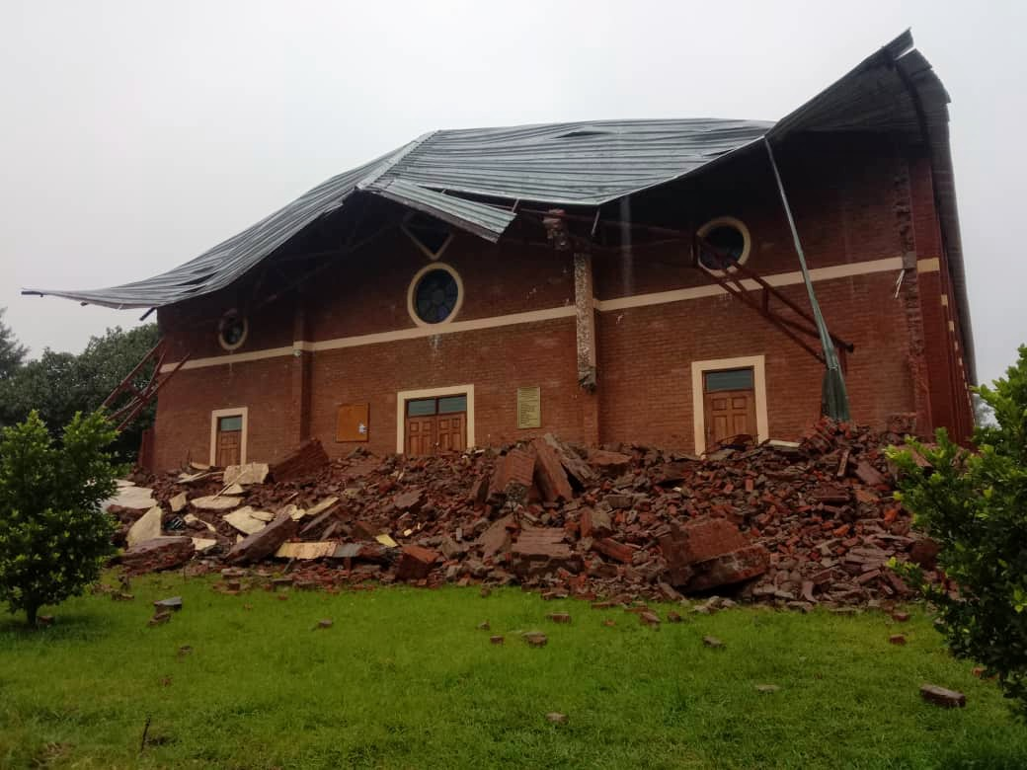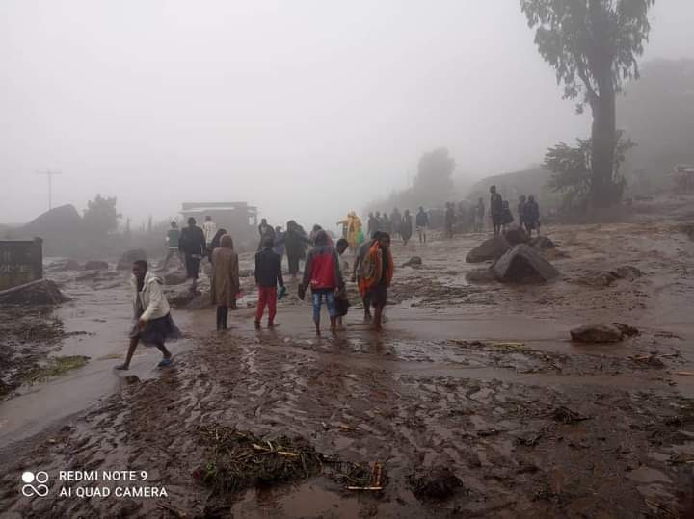
Left: Mendulo Catholic Parish Right: Partial view of where houses have been washed away in Ntauchila village, Chiradzulu.
The government through Department of Disaster Management Affairs and Malawi Defense Force have been helping in searching and rescuing people that have gone missing. The Catholic Bishops through Episcopal Conference of Malawi have also urged Christians and all well-wishers to help those that are greatly affected with the Cyclone.

As the rains continue, worries are increasing of what will come next. We are mostly worried with our Formation House in Mzedi where water was coming out the community cellar and some rooms being occupied by Brothers. The people that are seeking refuge in the classrooms of our institutions, Mzedi Primary School and Montfort Demonstration Primary School, are lacking a lot. They are in dire need food, clean water to drink, clothes and other basic needs for their survival. The same with other areas that are keeping the victims. There was a somber mood today, 15th March, when the State President was visiting some of the areas affected in Blantyre. Most people have been left traumatized and in fear though the weather seem to be calming.
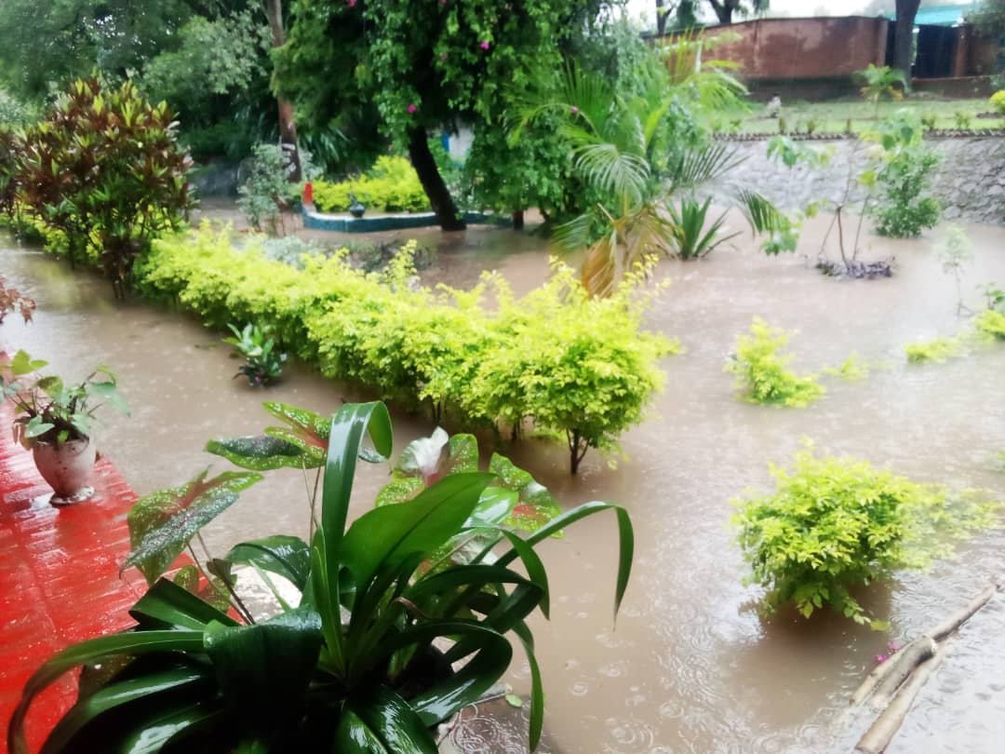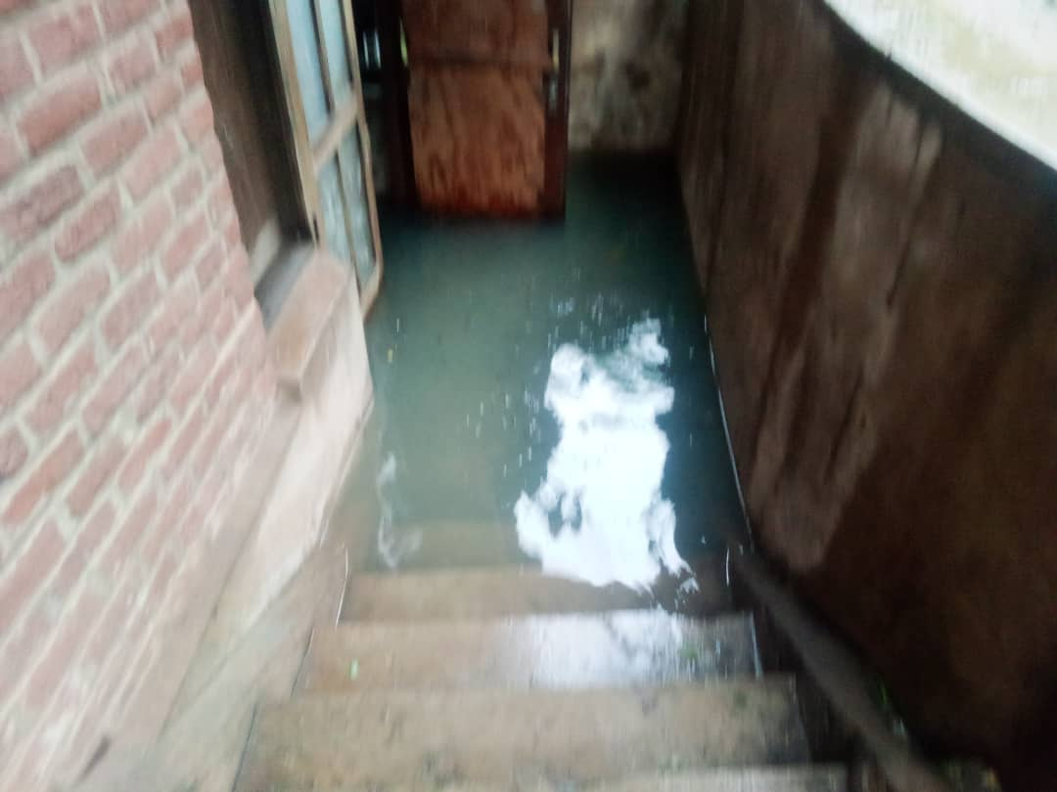
Partial view of Mzedi community of Brothers FIC.

Compiled by Bro. Gasper Kalisto
On behalf of Provincial Council – Malawi

