FUNERAL RITES AND TRIBUTES FORTHE LATEBRO. OSCARNAAPEULMWAN GEM, FIC
(16TH NOVEMBER, 1952 - 14TH JANUARY, 2015)
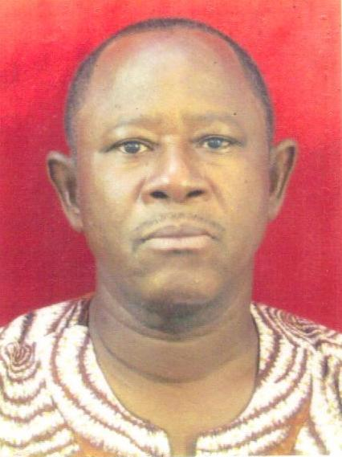
AT THE BROTHERS FIC, ST. LOUIS
COMMUNITY -WA. UWR. GHANA.
6TH – 7TH FEBRUARY, 2015
Our Deceased Brothers
Not only do we want to keep alive the memory of our Founders, but we also feel an everlasting relationship, with our deceased fellow-brothers; grateful for their inspiring example, we honour their heritage as well.
We commemorate them in our prayers and recommend ourselves to their intersections.

Constitutions of Brothers FIC Art. 11

LIFE HISTORY OF THE LATE BRO.OSCAR NAAPEULMWAN NIBEENYEL-ARIGEM, FIC. 16THNOVEMBER, 1952 – 14TH JANUARY, 2015

Bro. Oscar NaapeulmwanNibeenyel-Arigyem (Gem), FIC was born on 16Th November, 1952 at Chetu to Mr. Michael Gem and Madam Yolanda Tibe both of blessed memory. His father was a farmer and his mother a house wife. He was the 2Nd child and first son of his parents. He had 4 sisters and a younger brother - Cyril Gem who now keeps the fort of the family at Chetu.
Bro. Oscar started formal education at the age 7. He attended St. Thomas Aquinas Primary School in Fielmon from 1959 - 1965 and from 1965 - 1969 attended Nemora LA Middle School also in Fielmon. Before he could complete middle school, he got admission into Secondary School twice, but could not make it due to financial constraints.
The spark which culminated in Bro. Oscar's entry into Religious Life started in 1966 when Rev. Bro. Christopher Maalikuu of blessed memory then an FIC Brother, visited their school and gave them a talk about vocations. Although at the time, he understood little about Religious Life, his experience of Bro. Christopher left him with the desire to be like him one day. After middle school, he applied to join the Brothers FIC but was turned down because a higher qualification was demanded of him. As a result he abandoned the idea of becoming a Religious and moved to Nandom in search for a job.
At Nandom, he worked for 2years as a sales assistant in the store of a distant Uncle - the late John Nibunu. Having made and saved some money and determined to further his education, Bro. Oscar arranged and got registered for the then Common Entrance Examination at his Alma-Mater in 1972. His success in this exams took him to Sunyani Technical Institute where he read Business studies completing in June, 1977 with good grades in the O’Level examinations
From a very humble family background and with the kind of training given him by his parents, Bro. Oscar was not only gifted intellectually but also a man of personal conviction, indomitable character and great endurance. He would not yield to any life challenge in whatever form it presented itself nor resort to self-pitying, waiting for help to come from somewhere. On the contrary and even as a young man, he was daring and sought to open new windows in circumstances of hopelessness and desolations, readily accepting the consequences. These characteristics spurred him on throughout life.
In 1977, he took up a teaching appointment at Sunyani Commercial College. However, this appointment was short lived due to poor terms of the contract. He resigned the post before the year could end and went to Wenchi-Ofuman where he lived with his Mother helping her on her farm. During this period, Bro. Oscar had the option to start Postulancy with the Brothers FIC but indecision held him back. In 1978 he gained admission into Akrokerri Teacher Training College where he read Business Studies - Secretarial option, completing in June, 1981.
Nandom - Brutu Junior High School was his first appointment after his Teacher Training in 1981. At this time the abandoned interest to become a Religious had been rekindled. Driven by passion to rebuild his father's house as well as his village school, Bro. Oscar sought transfer to Chetu Primary School in 1982. By June, 1984 he had succeeded in mobilizing the people of his village to construct classrooms to house the village school which hitherto was under trees.
He started his initial formation into Religious life with the Brothers FIC on 14Th October, 1984 at St. Louis Formation Centre - Wa. On 15Th September, 1987 he made his first profession of religious vows and final commitment on 11Th December, 1993 at Fielmon.
After his first profession in 1987 Bro. Oscar was posted to Tumu community and appointed as Headmaster of St. Gabriel's JHS. From 1988 to June, 1991, he studied at the Kumasi Advance Teacher's College for a Diploma in Secretarial/Management. On his return he was transferred to Wa, St. Louis Community where he lived and worked as Headmaster of St. Andrew's JHS till 1994. He was a member of the Provincial Council from 1994 - 2000.
As years passed by with increasing responsibilities put on him, there was the need for him to upgrade himself academically. The quest for professional and academic upgrading took him to the University of the West of England from September, 1996 - June, 1999 where he studied for a BA (Hons) in Business Administration. In October, 1999, he was appointed Manager of the In-Service Training Centre (ISTC) - Wa. A position he held until November, 2001 when he resigned due to compelling circumstances. The next 3.5years that followed were marked by turbulent moments in his life as a Religious.
When the debris of the storm had settled by September, 2005, he was transferred to Damango where He taught at St. Anne's Senior High School. While in Damango, he took a 3 month Sabbatical at Hawkstone Hall in UK from April - July, 2009. On his return in August, 2009, He was transferred back to Wa Provincial House Community where he lived and headed for the second time, St. Andrew's JHS until June, 2011 when he had to relinquish this role due to deteriorating health.
The ailments that culminated in Bro. Oscar's death on 14Th January, 2015 can be traced back to 1998, when he was first diagnosed with diabetes. This condition was monitored and managed on regular basis. In later years before 2010, he developed chronic high blood pressure in addition. At the latter part of 2010 at Kole Bu Teaching Hospital, he was diagnosed with End-Stage Kidney Disease (ESKD) which required lifelong dialysis, at least twice a week to keep him alive. At that time, he was also wrongly diagnosed with hepatitis C which greatly impaired possible treatment in Ghana as there was no dialysis Centre in the Country at the time that handled hepatitis C, ESKD patients.
Faced with grave life threatening challenges, the Provincial Council at the time, was left with no local option but to fly Bro. Oscar to Abuja - Nigeria in January, 2011 for interim treatment pending availability of a treatment Centre in Ghana. Thanks to the generosity and support of Rev. Fr. Octavious Moo and staff of AECAWA who readily accommodated Bro. Oscar as well as offered him the needed support while in Abuja for treatment.
He returned to Ghana after 3 months and subsequent tests for hepatitis C proved negative. He was then allowed to use the dialysis machine of one Dr. Kwame of blessed memory who was then also a dialysis patient. The Provincial Council by then had purchased and working on the installation of the dialysis machine in the Brothers FIC, Accra community solely for his treatment. This also necessitated his formal transfer from Wa to Accra Community. For the last 4years of his life (January, 2011 - January, 2015), Bro. Oscar had to depend on dialysis as far as this could sustain him. On 14Th January, 2015 at about 8:30pm in his room while talking with Bro. Henry Surnye, he suddenly started gasping for breath and in a twinkle of an eye, he was gone forever. Thus, the life journey of 62years, 1month and 28 days had come to an end.
We are grateful to MadamIvy the Nurse who cared for Bro. Oscar all the four years he lived in Accra Community for his dialysis. She did this work with love and care. Even at the time she was highly pregnant and shortly after giving birth, she returned to work, sacrificing her maternity leave for our Brother. We are also grateful to his follow brothers in Accra Community who for the past 4years had to bear with the myriads of challenges that came with living with a terminally ill fellow brother in Community. The countless sleepless nights they had to endure coupled with the many times they had to make adhoc arrangements to rush him to the Police Hospital in Accra, whenever his dialysis machine at home broke down are commendable.
Of his 27years of religious life, Bro. Oscar spent greater part of this time in teaching mostly as a Headmaster. For him, that was where he found fulfillment in serving his God. He had always maintained that one can only find greatness through dedicated and humble service. Bro. Oscar was a gifted man, hardworking and lived his life meaningfully within the limits of his capabilities. He will not cease to bustle even in the face of crippling frustrations, ailments and pain. In his reflective and quite time, he would commit his imaginative and creative ideas into writing. This is how he became author of three books, namely: Saints or fools, Futile expedition and The witness of forgiveness. The latter book was still in the process of being printed when he passed on.
This is the personality, whose funeral mass we want to celebrate. As St. Paul says "whether we live or die, we belong to the Lord", (Romans 14:8). Bro. Oscar has returned to his maker. The tributes to him will remain a living testimony of the fruitfulness of his life and will linger on for many years to come. He was a man of principles, a leader, an educator, a mentor, a writer, a man with great sense of humor, a religious and a man of personal conviction. By dint of hard work and love for empowerment of people, countless people have benefited from his self-emptying as a teacher.
With united hearts and minds, let us in this Eucharistic celebration, pray through the intercession of Mother Mary Patroness of our Congregation for the remission of His human failings. We pray for the FIC family, and relatives of Bro. Oscar, particularly his surviving brother and 3 sisters, that we may all continue to persevere in faith as we try to accommodate this bereavement.
Thank you.

By Bro. Seregeous Dery, FIC.
Provincial Superior
(On behalf of the Provincial Council)
27Th January, 2015

FRIDAY, 6THFEBRUARY, 2015
PART I

RECEPTION OF THE BODY AT THE CATHEDRAL
TIME: 2.00PM
AT THE ENTRANCE OF THE CATHEDRAL
A song by the Dagaare choir
CELEBRANT: May the God of hope give you peace and the Lord of life be always with you.

RESPONSE: And with your spirit.
CELEBRANT: My Brothers and Sisters in Christ, we believe that all the ties of friendship and affection which knits us as one throughout our lives, do not unravel with death. Confident that God always remembers the good we have done and forgives our sins, let us pray asking God to receive our Bro. Oscar Gem in his heavenly kingdom.

Pause
PRAYER:
Oh God, Glory of all believers and life of the just, by the death and resurrection of your son, we are redeemed: Have mercy on your servant Bro. Oscar Gem and make him worthy to share the joys of paradise, for he believed in the resurrection of the dead. We ask this through Christ our Lord.
RESPONSE: AMEN.
Sprinkling of holy water and incensing
CELEBRANT:In the water of baptism, Bro Oscar Gem died with Christ and rose with him to a new life. May he share with Christ eternal glory.
RESPONSE: AMEN.
Solemn procession into the Cathedral
PLACING OF CHRISTIAN SYMBOLS
THE BIBLE
Provincial Superior: In his life Bro. Oscar Gem tried to preach and live the Word of God. We give him this word to take along with him.

Main Celebrant:
Let us pray. Almighty Lord and Father, in life, Oscar Gem cherished the gospel of Christ. May your Son Jesus Christ now greet him with these words of eternal life, “Come, blessed of my Father! Live in peace forever and ever.”

RESPONSE: AMEN.

THE CROSS
PS: Lord Jesus Christ, you loved us unto death even death on the Cross. In baptism, Bro. Oscar Gem was marked with the sign of the Cross. Let this cross be a sign of your love and victory over sin and death which he now shares.

Main Celebrant:
Let us pray: Lord Jesus Christ, you loved us unto death. Let this cross be a sign of your love for Bro. Oscar Gem and for the people you have gathered here today. We ask this through Christ our Lord.

RESPONSE: AMEN.

THE EASTER CANDLE:
PS: At baptism, Bro. Oscar Gem received the lighted candle as a symbol of Christ the light of the world. Just as he was guided by this light here on earth, May this light, Christ himself, lead him into the heavenly Kingdom.

Main celebrant:
Let us pray: Almighty God and Father, it is our certain faith that your son, who died on the cross, was raised from the dead, is the light of the world and first fruit of all who have fallen asleep. May this same light lead our dear Bro. Oscar Gem to share in the joy of the resurrection, through the same Christ our Lord.

RESPONSE: AMEN.

THE FIC LOGO:
PS: At his first profession, Bro. Oscar Gem received this logo as a symbol of his commitment to serve God and humanity in the religious life. You dedicatedly carried out this commitment. May this logo which is the symbol of your dedication to God and humanity accompany you to your father.
Main Celebrant: Let us pray; Lord God, our Father, in faithful communion with Jesus Christ, with one another and with all humankind, Bro. Oscar Gem committed himself to continuous growth of the Kingdom of God, in himself, in his community, in the Church, and in the world in which he lived. He earnestly desired to be a brother to his fellow brothers and to all humankind both in receiving and in giving love. Grant that he may enjoy eternal brotherhood with Jesus Christ and all the Saints in heaven. Through Christ Our Lord.

RESPONSE: AMEN.

THE ROSARY:
PS: Mary is the Patroness of the FIC Congregation. We are happy to place our lives under her special protection. One way to show our devotion to Mary is through the praying of the Rosary. May your devotion to the rosary lead you to eternal life.

Main Celebrant:
Let us pray: Lord God our Father, in Mary’s Magnificat we taste her preference for the poor and needy, and the longing for justice and righteousness. She is the mother of the faithful. Through all her doubts and uncertainties she remained faithful to her Son, even onto Calvary. That is why all generations call her blessed. May she continue to inspire us too: it is her example we wish to follow and invoke her aid in our prayers. Through Christ our Lord.

RESPONSE: AMEN.
Concluding Prayer:
Lord God you are active to the voice of our pleading, let us find in your Son comfort in our sadness, certainty in our doubt and courage to live through this hour. Make our faith be strong in the Lord. We ask this through Christ our Lord.

OPENING PRAYER
Oh God, listen favourably to our prayers offered on behalf of your servant Bro. Oscar Gem. Grant that this servant of yours who committed himself zealously to the service of your name may rejoice forever in the company of your Saints. We ask this through Christ our Lord.
RESPONSE: AMEN.

READING OF THE WORD
- Rom: 5:5-11
- Reflection: By Celebrant
- The Lord`s Prayer
- Kuu-sagfopuoro
CONCLUDING PRAYER
God of mercy and love, grant your servant Bro. Oscar Gem a glorious place at your heavenly table, for you made him here on earth a faithful servant of the people of God in his ministry. Comfort all who mourn at this hour of grief, with courage and certain faith. Grant this through Christ our Lord.
RESPONSE: AMEN.
CELEBRANT: Eternal rest grant unto him, oh Lord
RESPONSE: And let perpetual light shine on him
CELEBRANT: May the soul of Bro. Oscar Gem and the souls of all the faithful departed through the mercy of God rest in perfect peace.
AMEN.

ANNOUNCEMENTS

Procession to St. Louis Community
Prayer Service in the Brothers’ Chapel (Only FIC)

Procession to funeral ground

BLESSING OF THE BIER
CELEBRANT: Father of heaven and earth, we thank and praise you for the gift of your creation. You gave us homes to live in here on earth. As we prepare this bier for your servant, Bro. Oscar Gem, may you have a place prepared for him in your heavenly home promised by Christ to his faithful. Who lives with you in your kingdom forever and ever. AMEN.

LAYING IN STATE

OFFICE OF THE DEAD

TRADITIONAL MOURNING BEGINS

PART II

VIGIL MASS WITH READING OF TRIBUTES
Liturgical Programme
Time: 8:30pm
Entrance Song: Dagaare Choir
Kyrie: Dagaare Choir

Opening Prayer
Lord God you chose our brother, Bro. Oscar Gem, to serve your people and share the joys and burdens of their lives. Look with mercy upon him and give him the reward of his labour, the fullness of life promised to those who dedicate themselves to your service. We ask this through Christ our Lord. AMEN.

1st Reading: 2Cor 5:17- 27.
ResponsorialPsalm: Dagaare Choir
Gospel Acclamation -
Gospel: Lk 12: 35- 40.
Homily
Bidding Prayers: From book of Rites.
Collection: Charismatic Choir
Presentation of Gifts : Charismatic Choir
Prayer over the gifts
Oh Lord, be merciful to the soul of your servant, Bro. Oscar, for whom we offer this sacrifice of praise. We implore your divine majesty to grant him eternal rest through this offering we have made, through Christ our Lord. AMEN.
Sanctus: Dagaare Choir
Our Father: Recite (Dagaare)
Sign of Peace:
Lamb of God: Charismatic Choir
Communion: Dagaare /Charismatic Choir

Prayer after communion
Almighty God, May this sacrifice purify the soul of your servant, Bro. Oscar which has departed from this world. Grant that once delivered from his sins, he may receive forgiveness and eternal rest. Grant this through Christ our Lord. AMEN.

READING OF TRIBUTES AND PRAYERS
* The Gem family
* Priests and Religious Association ( Fielmon).

Announcements
FINAL BLESSING:
Lord God, May our humble prayers help the soul of your servant Bro. Oscar Gem. Free him from his sins and grant that he may share in the redemption you won for all people. We ask this through Christ our Lord. AMEN.

TRADITIONAL MOURNING CONTINUES

SATURDAY 7TH FEBRUARY, 2015
MORNING PRAYER: 6:30 AM
READING OF TRIBUTES:
* FIC Community ( Accra)
* St. Andrew's Junior High School ( Wa)

Traditional Mourning continues.

PART III:FUNERAL MASS

TIME: 10:00 AM
Liturgical Programme
Main Celebrant: Most Rev. Paul Bemile, Bishop of Wa.
Entrance: Dagaare choir
Sign of the Cross and greetings.
Reading of Biography: Provincial Superior.
Kyrie: Dagaare choir

Opening Prayer
Oh God, in whom sinners find mercy and the saints find joy, we pray to you for our brother, Bro. Oscar whose body we honour with Christian burial that he may be delivered from the bonds of death. Admit him into the joyful company of your saints, and raise him on the last day to rejoice in your presence forever. We ask this through Christ our Lord. AMEN.

1st Reading: 1Thes. 4:14- 17
Responsorial Psalm: Charismatic choir
Gospel Acclamation: Dagaare choir
Gospel: Lk. 12: 35- 40
Homily:

Bidding Prayers
* Brothers FIC
* The Gem Family
* St. Andrew Junior High Wa
* St. Anne’s Senior High Damongo
* Priests and Religious Association ( Fielmon)

Collection: Charismatic choir
Presentation of Gifts: Dagaare choir
Prayer over the gifts
Lord, as we mourn the death of our brother, Bro. Oscar, through the gifts we offer, show us the immense power of your goodness and strengthen our belief that he has entered your presence. We ask this through Christ our Lord. AMEN.

Sanctus: Dagaare choir
Our Father : Recite
Sign of Peace:
Lamb of God: Dagaare choir
Communion: Charismatic /Dagaare choir

Prayer after communion
Lord, hear our prayers. By raising your Son from the dead, you have given us faith. Through the sacrament we have received, strengthen our hope that your servant Bro. Oscar will share in his resurrection. We ask this through Christ our Lord.
READING OF TRIBUTES BY
* St. Anne’s Senior High School (Damongo)
* Brothers FIC, Ghana Province.

ANNOUNCEMENTS
FINAL COMMENDATION AND FAREWELL
Invitation to prayer
CELEBRANT:
With faith in Jesus Christ, we most reverently bury the body of our brother. Let us pray with confidence to God, in whose sight all creation lives, that he will raise up in holiness and power the mortal body of Bro. Oscar Gem and commend his soul to be numbered among the blessed.
May God grant him a merciful judgment, deliverance from death, and pardon of his sins. May Christ, the Good Shepherd, carry him home to be at peace with the Father. May he rejoice forever in the presence of the eternal king and in the company of all the Saints. Through Christ, our Lord. Amen

Pause

FAREWELL SONG

(Sprinkling of holy water and incensing of body)

PRAYER OF COMMENDATION
CELEBRANT:
Lord, hear our prayer and welcome our brother Bro. Oscar into paradise and help us to comfort each other with the assurance of our faith, until we meet in Christ to be with you and with our brother forever.
We commend him to you, Lord. Now that he has passed from this life, may he always live in your presence. And in your mercy and love, forgive whatever sins he may have committed through human weakness. We ask this through Christ our Lord.
M.C. With hope in the resurrection, let us take our brother to his resting place.
Procession to the cemetery: Songs (Dagaare Choir)/KOWEL GYIL:

PART IV –BURIAL
Invitation to prayer
CELEBRANT:
Let us pray for our brother Bro. Oscar to our Lord Jesus Christ who said: “I am the resurrection and the life. The man who believes in me will live, even if he dies, and every living person who puts his faith in me, will never suffer death”.
Blessing of the grave
Celebrant:
Oh God, by whose mercy the faithful departed find rest, bless this grave and send your holy angels to watch over it. As we bury here the body of our brother Bro. Oscar, deliver his soul from every bondage of sin that he may rejoice in you and with your Saints forever. We ask this through Christ our Lord. AMEN.

Celebrant sprinkles the grave with holy water and incenses it (The body is now lowered).
Committal
CELEBRANT:
In the sure and certain hope of the resurrection to eternal life through our Lord Jesus Christ, we commend our brother Bro. Oscar to you, Almighty God, and we commit his body to the ground; earth to earth, dust to dust.
May the Lord bless him and keep him. May the Lord let his face shine upon him and be gracious to him. May the Lord lift up his countenance upon him and give him peace. We make our prayer through Christ our Lord. AMEN.

Internment.
* Laying of wreaths to be done in silence
* Final Prayer over the people.
M.C. Bow your heads and pray for God’s blessing.
CELEBRANT:
May the peace of God which is beyond all understanding, keep your hearts and minds in the knowledge and love of his Son, our Lord Jesus Christ.

RESPONSE: AMEN.
C/. Eternal rest grant unto him oh Lord.
R/. And let perpetual light shine upon him
C/. May Bro. Oscar rest in peace?
R/. AMEN.
C/. May the soul of Bro. Oscar and the souls
of all the faithful departed through the mercy
of God rest in perfect peace.
R/. AMEN.
C/. May almighty God bless you, the Father, the
Son and the Holy Spirit.
R/. AMEN.
M.C. Go in the peace of Christ.
R/. Thanks be to God.

TRIBUTE TO THE LATE REV. BRO. OSCAR N. GEM
FROM THE GEM FAMILY.

“So teach us to number our days oh Lord, that we may apply our hearts to wisdom” (Psalm 90:12).
Rev Bro. Oscar Gem, the dawn of the 15th day of January 2015 greeted us with unfamiliar signals in nature’s routine occurrences. The moon had failed to smile with delight unto the face of the earth, the rising morning sun had lost its brilliance and elegance, and the excited birds that usually greeted the morning breeze with their sweet melodies, announcing the arrival of a new day had lost their charming voices. It was only until then, we came to terms that, “a branch had fallen off from the great oak of our kindred”, but on the wrong side of the road.
Bro, the book of Ecclesiastes couldn’t have stated it better than to opine that “ there is time for everything”, a time to born and a time to die, a time to plant and a time to harvest, a time to cry and a time to laugh …… (Eccl 3: 1 -8). Not that this cardinal fact of our mortal journey on earth here eluded us, but how could we have thought that death would lay its icy hands on you at this moment that we needed you most? How could we have believed that you would leave us without saying a good bye?
News of your unexpected journey to the lord our maker came to us from faraway lands as a rumour. As the day grew older, it came louder than what could be a simple rumour. But we stand here this night, with heavy hearts of sorrow and feet trembling with sadness because, before us, you lie cold and motionless. You have neither responded to any of our loud calls nor welcomed any of us with your usual broad smiles.
Oh death! How could you be so wicked that you take away even what belongs to the poor widow and the orphan? What could be our wrong that makes you choose to hit us so hard and leave us in bitterness and despair?
Like the mother hen gathers her chicks, Bro, you have been an epitome of unity that left no stone unturned in gathering us together in unity. Your zest at building our family into a cynosure of a single united entity is evinced in your open heartedness and warmth with which you accepted us all as your own. Even as a single person, your doors were so wide and your heart so welcoming that, we all found appropriate entry into your life. To some of us, you have been the loving father that brought smiles unto our faces whenever we were despaired. Unto others, you were the loving husband whose value is irreplaceable in ransom. In entirety, you were a brother, a counselor, a mentor and an inspirer who has never turned away from helping us achieve our dreams, no matter how little your strength may be.
Bro. whilst on earth, you chose a unique vocation. You dedicated your life to the service of God and never relented in your effort at getting us all to Christ. You were a pointer to Christ and your faith in God was never doubted even in the challenges that you encounted whilst battling ill health. Indeed, you demonstrated courage, unflinching faith and an unconditional love for God. You taught us to love and serve God at all times. Like a lamp put on a stand, you were the light that brightened the family, drawing us to the warmth of Christ Jesus.
Your friends loved ones and compatriots mourn you but we your kinsmen are inconsolable for your departure was without a warning. How could we have suspected that the end could be now when your presence made fresh the values of humility, excellence, discipline, intelligence among others?
Time may have drawn a curtain over the stage upon which you acted, but the memories of your great acts will ever linger in our minds. We your kinsmen will forever remember you as our great teacher, father, counselor, friend and role model.
As we come today to bid you farewell, our hope is in scripture as promised in John 11:25 that ‘I am the resurrection and the life: he that believes in me, though he were dead, yet shall he live ` .In this promise of hope, we know that you are not dead. But you are living in Christ waiting the hour of the great trumpet when we shall all meet again in the fathers’ glory.
Farewell in this journey of eternity, farewell and May the spirit of God guide you in this long, cold and lonely journey.
Brother, kyenvella, kyenvellatikpe a Dagnenurupuo.

TRIBUTE TO THE LATE REV. BRO. OSCAR N. GEM FROM FIELMUO PRIESTS AND RELIGIOUS UNION
As for me my life is already being poured away as a libation, and the time has come for me to be gone. I have fought the good fight, I have finished the race, I have kept the faith, from now on, the crown of righteousness awaits me which the Lord, the just judge will award to me that day, and not only to me, but to all who have longed for His appearance (2 Timothy 4: 6 -8).
Shortly after his demise on Wednesday, 14th January 2015, this word of St. Paul hit hard on all Union Members as we stared into nothingness while recalling in confusion and utmost disbelieve what has befallen the Union and FIC at large. Bro. Oscar might be laughing within himself as any Union member hearing the news was momentarily immobilized. Indeed Bro, Oscar has fought a good fight by giving sickness and death a good run for years for the arrogance and presumed power. As the saying goes “Fosaa do salengzutiluore, kuugania be” Oscar has climbed the heavens, gone round the earth to avoid death not knowing that death was calmly waiting to pick him up right in his bed room. At the appointed time, death sneaked between two people and laid its icy hands on him and in a matter of a minute, he was gone. This was the man and this is the shock to be overcome by your fellow members of the Union.
If we are confused and mourning at this moment, it is a fact that in nature, those whom we love remain part of us, because when our loved ones leave this world, they truly do not leave our hearts and so you are. Your departure has left a vacuum, but we will fill it with remembered memories of your contribution to the development of our Union.
You volunteered to host the Union annual meeting which was scheduled to take place on 2nd January 2015 but had to be cancelled because of your ill health. Yet, you were still encouraging us to try and host the meeting in your house. Little did we know that you wanted us to sit with you and in your house for you to say farewell to all of us. In our meetings, you most often took charge in encouraging conferrers to share their pastoral experiences visit each other and to support each other! How can we accept missing these encouraging words?
As a man who had gone through myriads of challenges as a religious, you never hesitated to encourage, share and console those of us who were facing challenges in our ministry/apostolates. We all benefited from your wealth of knowledge and experiences. You drew all these wealth and knowledge from the fact that, you were a dedicated teacher who loved his job, very simple, hardworking, disciplined, adventurous, courageous, affable, and firm in what you believed in. For you, a spade could never be called a big spoon. Justice was your watch word!
Bro. Oscar, the Union is missing a pillar; we are in tears, and even struggling to console those whom you have touched in their lives. If it were possible, we would have asked you to come back and answer just some few questions which we are struggling to find answers to, before you give us your final fare well, but alas God ways are not our ways. A Kpanyaneni a Gbaaneyirnyognivuung! Pognyamekonena! BibiirKyiire! Sondarizaahiine! E a tim, naiakpaarubiirapaa tie siirari gem!
In all this grieve and pain, we however find consolation in the Good Book that “there is time for everything and everything that happens in the world happens at the time God chooses. He sets time for birth and time for death. The time for planting and time for pulling up that which is planted (Ecclesiastes 3: 1-2). Bro. Oscar, your departure has broken our hearts, but we will console ourselves and mend them with the hope in the resurrection, where we shall all meet and rejoice. Brother, Fare well! Fare well! Fare well! We love you but God loves you best. May you rest in perfect peace.
By Bro. Philaviano Fabian Kuupille
(On behalf of Fielmuo Priests/Religious Union)

TRIBUTE TO THE LATE BRO. OSCAR N. GEM FROM BROTHERS FIC - ACCRA COMMUNITY

“Teach us to number our days and recognize how few they are, help us to spend them as we should. Teach us how short our life is so that we may be wise” (Ps 90: 12).
The late Bro. Oscar has been part of the Accra community since July 2011; most likely, not by his own choice or that of the Provincial Council, but by virtue of his own condition – to have the best of medical attention as a dialysis patient.
With Bro. Oscar, the community was never as it used to be; his condition, care and attention affected every aspect of the brother’s apostolic and community life – “the effect of a deep and sincere human care, attention and love that was shared, reminding us of God’s great love in Christ that is changed by other people’s love when freely and transparently given”. There were times brothers of the Accra Community felt Bro. Oscar was too hard on himself. However, we were committed to seeing him live a day more as we say good morning to each other every morning, asking how he was doing and whether he needed any help.
The late Bro. Oscar had an interest thatgrew from a feeling that he had a contribution to make, creating the enthusiasm and desire to live an exciting life in spite of his condition as we observed. He was curious, adventurous; values that made life interesting for him and for us. Interested in his many life experiences, he often woke up with thrilling feeling of doing something new and fulfilling something not accomplished yesterday – the urge to start a poultry farm, a sheep pen, keeping the bursary, shopping for the kitchen and at times cycling around to fetch animal feed.
Bro. Oscar gave the intensity of every moment he was called upon but was careful he did not allow himself to be used. He was not naïve. He listened to others; at times, sitting back but made sure he never lost his own voice. He was not lonely, he was at-home with himself, his thoughts, not an alien to his own feelings and not a stranger to himself either as we knew him. He was an assertive brother.
On one occasion, one of the Brothers of the Accra Community had brought him to the Police hospital in Accra for dialysis. On arrival, the inspector in charge of the hospital asked how he was faring; in reply, He said to the inspector, nothing much has changed Sir. Bro. Oscar had remained silent, only with a faint smile; on arrival till he left the hospital after four (4) hours. Indeed, the late Bro. Oscar was a man of few words with an inner strength who understood what it meant to suffer in silence, accept and to endure whatever situation he was going through. His disposition and composure made us understood his family stories of pain, loss, hardship and the practice of Hope – “always taking the first step, even without seeing the whole staircase”.
In spite of Bro. Oscar’s condition, he endeavoured the “upward reach of God”, carried his brothers along any time he was called upon to lead the community in prayer. He did what came naturally and felt was the best for the moment. He took the risk of being a free person and allowing God to do the rest.
Now, the labourer’s task is over, Bro. Oscar. Now, the battle day is past. Now, upon the farthest shore lands the voyage at last. Earth to earth and dust to dust come now with the words we say - Left behind, we your brothers wait in trust for the resurrection day.
Rest in Perfect Peace, Dear Bro. Oscar.

Bro. Peter Agboso, FIC
On behalf of Members of the Accra Community.

TRIBUTE TO THE LATE BRO. OSCAR N. GEM FROMTHE STAFF OF ST. ANDREW’S JUNIOR HIGH SCHOOL, WA
We, the staff and pupils of St. Andrew’s Catholic Junior high School have come to mourn our beloved former Headmaster, Bro. Oscar Gem.
We are here to appreciate a selfless and dedicated personality who sacrificed almost his entire life to the development of the youth of St. Andrew’s Catholic JHS in Wa.
Bro. Oscar was first posted to this school on the 17th of July 2003 to serve as Headmaster until 7th September 2004 when he handed over to Mr. Anthony DakurahYidaana and proceeded to teach at St. Anne’s Girls Senior High School – Damango.
Bro. Oscar came the second time to head the school from 19th October 2009, until he went on retirement in November 2012, and handed over the school to Madam LeoniciaLangkpier as the substantive head.
Bro will always insist on the right thing to be done at the right time, that is, punctuality and regularity of both teachers and pupils, making sure that teachers are in class and actually teaching, insisting that enough exercises are given to pupils.
Bro, even on his sick bed used to come to school to give teachers and pupils moral support to do their work and also find out their problems.
When teachers visited him or called him on phone to find out his condition, Brother will always said “With your prayers I am doing well” and this gave all the teachers and pupils some hope.
Teachers and pupils lost hope when Bro. Oscar was taken out of the region for further medical attention. Though far away, He still visited the school and interacted with teachers and pupils anytime he was in town.
Bro. Oscar retired as the Headmaster of JHS in 2012, but did not lose contact with the school.
Our last meeting with him was at the funeral of the Bro. Nicholas Zumanaawhen most teachers were excited to see Bro. Oscar looking fine.
In January 2015, when schools reopened the sad news of his demise got to us on the 15th January, 2015.
Brother, as we affectionately called you, we have missed you.
The staff and the pupils of St. Andrew’s Catholic JHS say, REST IN PERFECT PEACE.

TRIBUTE TO LATE BRO. OSCAR N. GEM FROM ST. ANNE'S GIRLS SENIOR HIGH SCHOOL, DAMONGO
God passes by, but we cannot see Him. He takes what He wants and no one can stop Him. No one dares ask Him, what are you doing? (Job 9: 11-12).
We received the terrible news of the sudden death of our dear brother, colleague and teacher, the late Rev. Bro. Oscar Gem with shock. We all knew our colleague was not well but little did we know that he was going to leave us too soon.
Bro. Oscar joined the staff of SAGISS and was introduced as the new teacher of Business Management in 2007. From the word go, indications showed that he was a hardworking and selfless man. He became the natural brother of the school and handled the students as his sisters. Through his counselling, and being a source of encouragement and inspiration to the staff and students, the school moved on in spite of the difficulties at the time. Brother was soft spoken, very generous and gave out freely. He was a comfort to the needy and distressed in the school.
Despite the fact that Bro. Oscar Gem was of high upended in society, he was very simple, respectful, humble and thoughtful much to the admiration of all who worked with him in one way or the other. Death has really robbed us of our former colleague whose sterling qualities and contributions kept the school on another level during his time with us.
May you find your mansion joyous, comfortable, smooth and free from the pains and stress of this turbulent world. May the angels of heaven receive you into the bosom of the Almighty till we meet again.PEACE PERFECT PEACE!

TRIBUTE TO THE LATE BRO. OSCAR NAAPEULMWAN NIBEENYEL-ARIGYEM (GEM) FROM BROTHERS FIC, GHANA PROVINCE
“In the very temple of delight, veil’dMelancholy has her sovereign shrine” (John Keats)
The above saying from John Keats has summarized our present mood as a Province. Sorrow visits you at the time you least expect it. At the moment, we are sorrowing; happiness is replaced with sadness because the one we love is no more. Bro. Oscar, we, your confreres of the Ghana Province of the Brothers FIC are shocked. We feel helpless and confused not just because of your passing on to eternity at this time of your life, but that you passed on while having a chat with your fellow brother over the next line of action to restore good health in you. No one suspected that death was at your door. It took you in a manner that a passer-by would take you for a comedian or that you were trying to dramatize sleep for others to observe, yet it was the reality, yes death has laid its icy hands on you.

Exactly one and half months after the demise of Bro Nicholas Zumanaa which you participated in the funeral rites performance; and just when we were about to accept that painful and unbelievable loss, you followed sued without a word, creating an unimaginable vacuum that cannot be filled in the Province and thereby increasing the pain in our hearts. All of us were fully aware and accepted your health condition and if there were ever a supermarket on earth where life is sold, we could have bought you one. In fact, the dialysis machine provided you by the Province; and on which you lived on for a number of yearsconstitutes a clear demonstration of our longing to keep you live as far as machines and human efforts could take you.

However, since this earth is not our home and as scripture will have us believe, our home land is in heaven, it is from there that we are expecting a Saviour, the Lord Jesus Christ (Ph. 3:2). We neither have power nor option to bargain with God or resist His plan to take you to Himself. We need you more but the Lord your Creator needs you most. Again, “…to everything there is a reason; there is a time for every purpose under heaven. A time to be born and a time to die… Eccl. 3:1-2”. The above teachings from scripture are as consoling as they remind us also that it is impossible to have you living forever on earth. Indeed, they further create the awareness that we who you have left behind are only postponing our share of what you have done now.
Our constitution says:
Not only do we want to keep alive the memory of our founders, but we also feel an everlasting relationship with our deceased fellow-brothers; grateful for their inspiring example, we honour their heritage as well. We commemorate them in our prayers and commend ourselves to their intercession (art. 11)
At this moment, we are compelled by circumstances to ask you to intercede on our behalf before God our Father.

Bro. Oscar Gem, you were a self-made man, intelligent, gentle, principled, calculating; humorous and above all, a man of God. You were full of passion for truth and justice and will not countenance an infraction of any of these natural virtues by anyone before you. Sometimes the strategies you employed in ensuring that these virtues are adhered to at your apostolate and in your daily interactions with people were controversial and became topical issues among us your confrères and the general populace. Other times, your ideas you brought to bear on resolving issues in the community made you look like a nonconformist and a man with a difficult personality. It often dawned on you that, truth has a strategic position of balancing its head on the shoulders when it is been sought after; yet you would often remain resolute in pursuing truth and justice to the letter. In your life time you reveled your past with nostalgia and was also often, in your conversations and narrations, preoccupied yourself with your cultural pedigree.

Bro. Oscar has written several inspiring reflection papers for the brothers in the Province for our monthly recollections. His intellectual prowess turned him into a fledgling artist, a hobby he nursed and nurtured which also became a channel through which he communicated to his readers that he too, like anyone else had a story to tell about his past. In your three books (Saints of Fools, The Futile Expedition and the Power of Forgiveness) Bro. Oscar, you apparently sought to explain how you conceptualized life and the experiences you went through. In your life time you served humanity in various capacities. You were a head teacher in several basic schools and later became the manager of ISTC. In your last community in Accra, you became a poultry farmer, a hobby and a self-reliant venture you undertook to augment the meat supply in the community kitchen.

Bro. Oscar has left a deep wound in our lives and that of many others but the Lord our Healer will heal and renew us. We pray that the Good Lord welcomes him and give him a peaceful place to rest. Bro. Oscar, go well and rest in the bosom of our Lord Jesus Christ. But when you get there, tell our founders in plain language especially Msgr. Rutten and Bro. Bernardus that we are still committed to the continuous growth of the kingdom of God in the world in which we live. We will forever keep you in our prayers and do not forget to intercede for those of us you have left behind.

Once again, Bro. Oscar, fare thee well! Bro. Oscar, kyenvula! Naamwintuori deb tikpen a yir song puo!!!

By Bro. Kuu-IremeSaabekone Godwin (FIC).

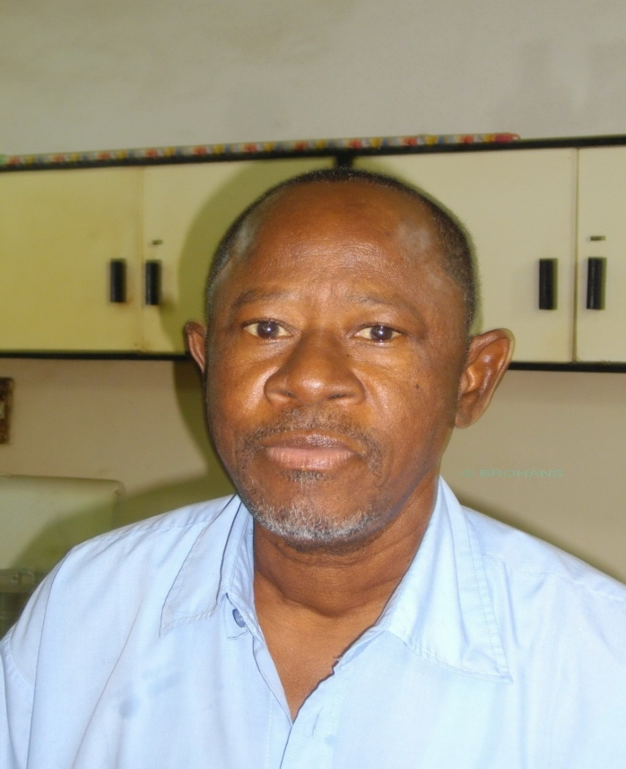

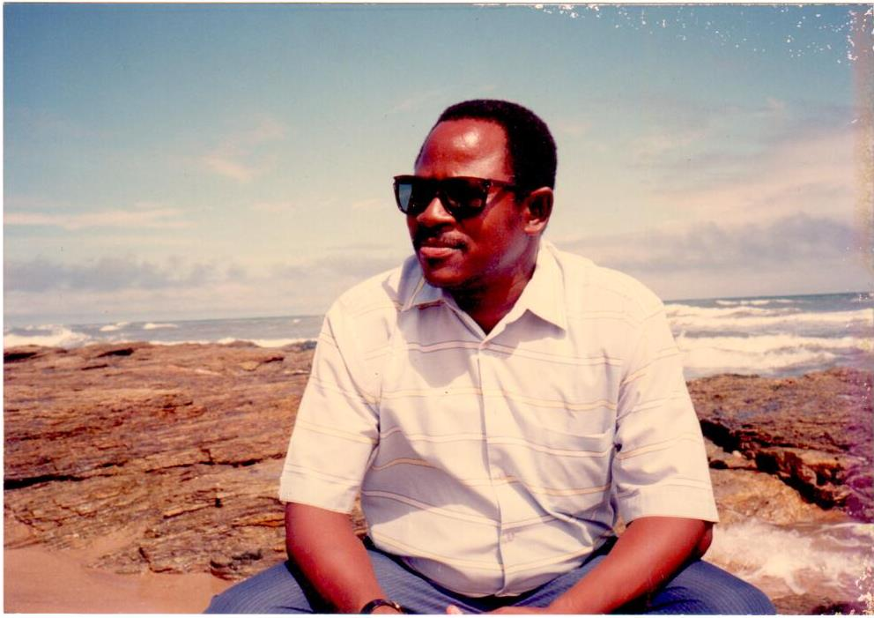
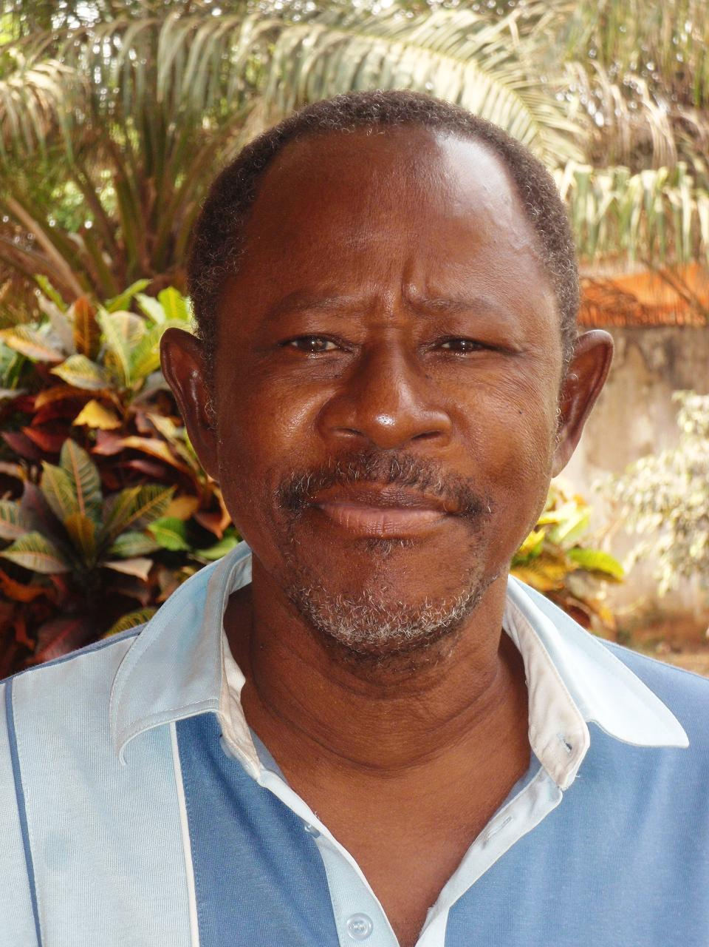 | 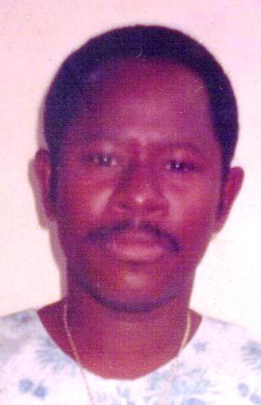
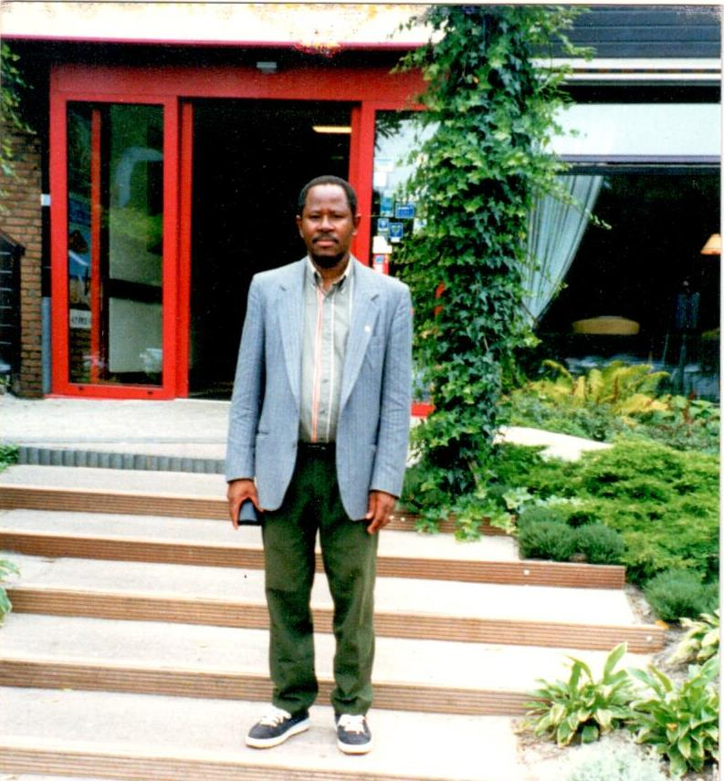 | 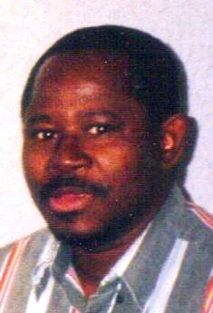
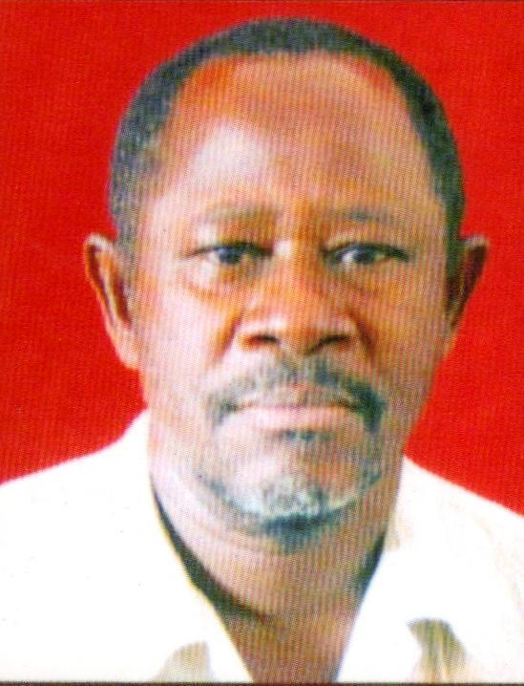

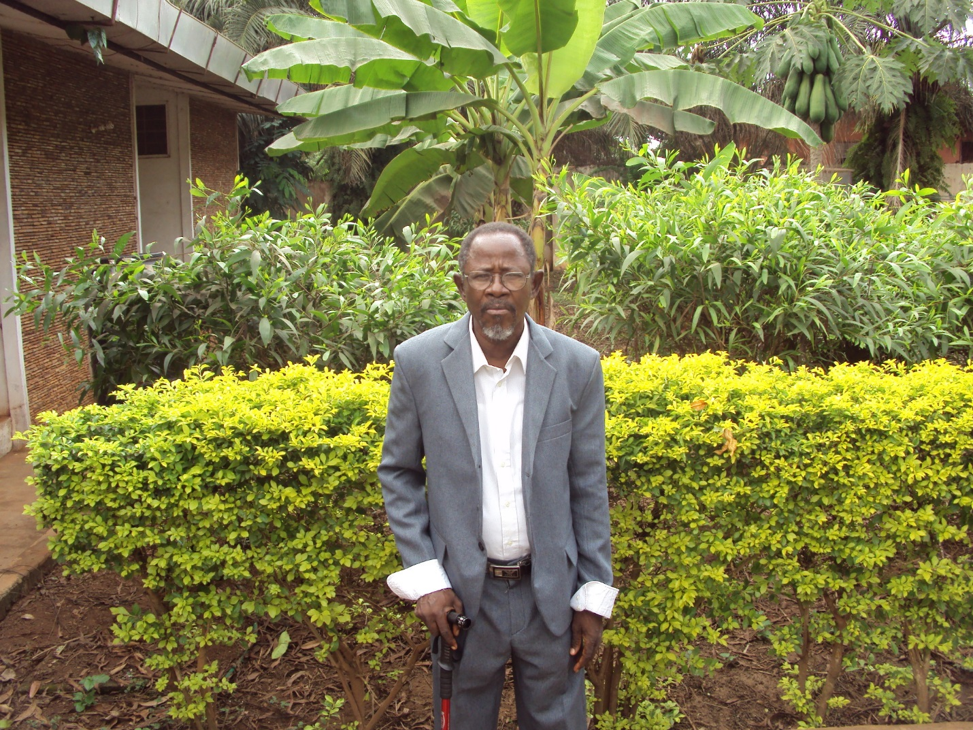

Appreciation

The Provincial Council and the entire Brothers of the Congregation of the Brothers of the Immaculate Conception of the Blessed Virgin Mary (Brothers FIC) express their sincere gratitude to you for your prayers, support, physical presence, donations in cash and kind and condolences received throughout the ailment, demise and funeral of our beloved Brother, Bro. Oscar N. Gem -FIC.

Thank you very much. May God richly bless your kind generosity and replenish your expended energy in whatever effort you made to support us.

From: The Provincial Council.
Brothers FIC.
Ghana Province.
7Th February, 2015.



